READY TO USE CRAFT

The message of Jesus spreads
This month we explore some stories from early on in the book of Acts, where we see how the good news of Jesus spreads. Use these activities alongside a Together session or as part of a craft afternoon. You could give them out to parents and carers, with a pack of resources, so that they can do them at home.
_______

TOGETHER SESSION ONE

Flame jar
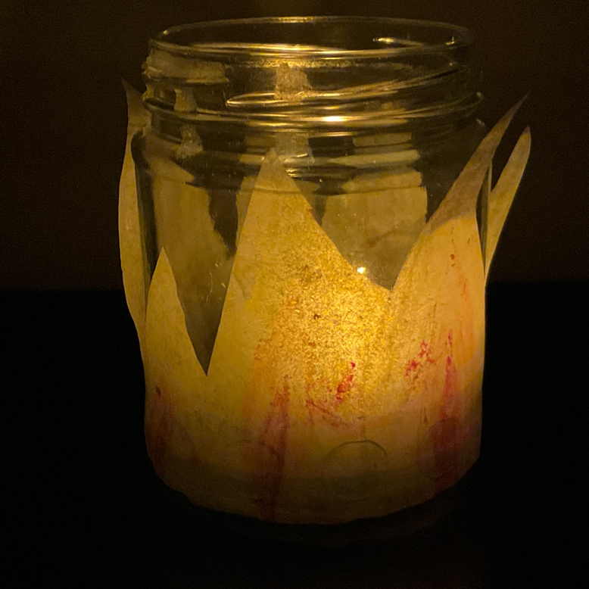
You will need: wax crayons in shades of yellow, orange and red; greaseproof paper; scissors; glue dots; tealights (battery-operated or real); clean jam jars with labels removed

On the day of Pentecost, flames appeared above the disciples’ heads as a sign of the presence of the Holy Spirit. This craft is a reminder of those flames. Cut strips of greaseproof paper that are not quite as tall as your jam jar and are long enough to wrap all of the way round the jar with no gaps. Decorate the greaseproof paper with ‘flames’ drawn and coloured in with the wax crayons. Cut away all of the extra greaseproof paper so that the ‘flames’ are shaped (see photo). Put glue dots all the way around the bottom edge of the outside of the jar. Next, wrap the greaseproof paper flames around the jar, sticking them to the glue dots. Put a lit tealight (with supervision!) or your battery-operated tealight inside the jar. When it is dark, watch the flames light up.

TOGETHER SESSION TWO

Paper weaving
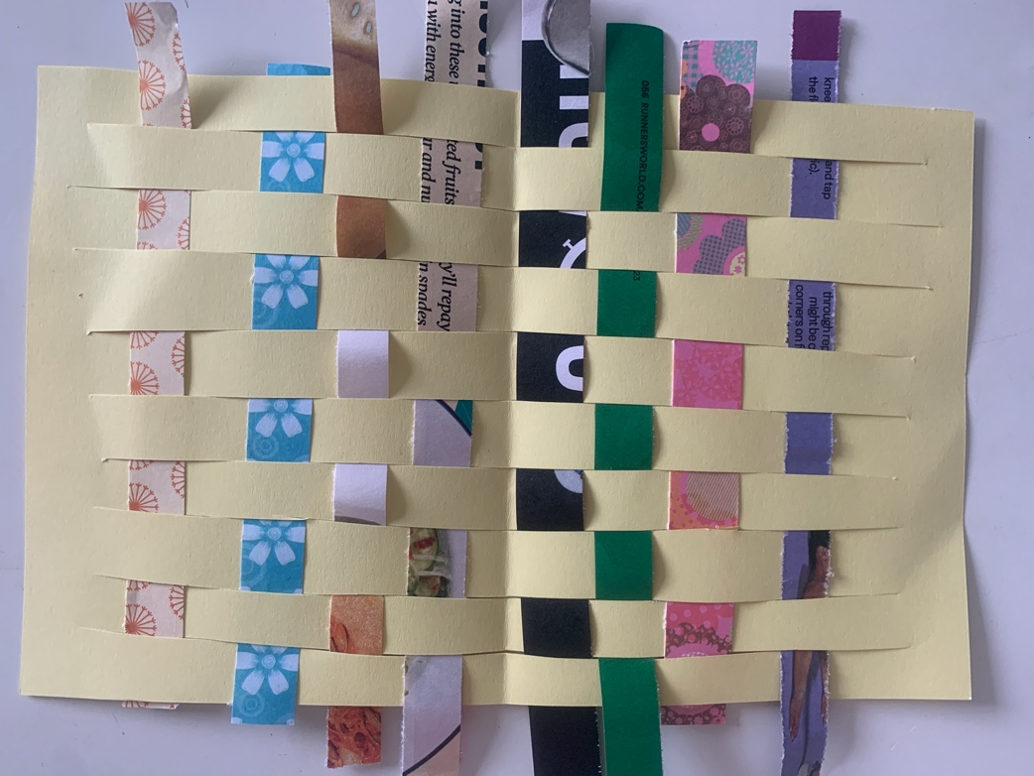
You will need: A5 paper; magazine pages; coloured and patterned paper; scissors; paper cutter (optional)

The weaving together of people into community as more and more people come to faith is reflected in this weaving craft. Fold a piece of A5 paper in half and cut some slits in it, making sure that you don’t cut right to the ends. Open the sheet out. Cut strips of magazine pages, coloured and patterned paper. Weave them in and out of the slits you have made in the A5 paper until you have filled the page. You might want to use different colours or patterns to reflect the different types of people who were joining the Christian community or the different things that people were sharing between themselves.

TOGETHER SESSION THREE

Praising puppet
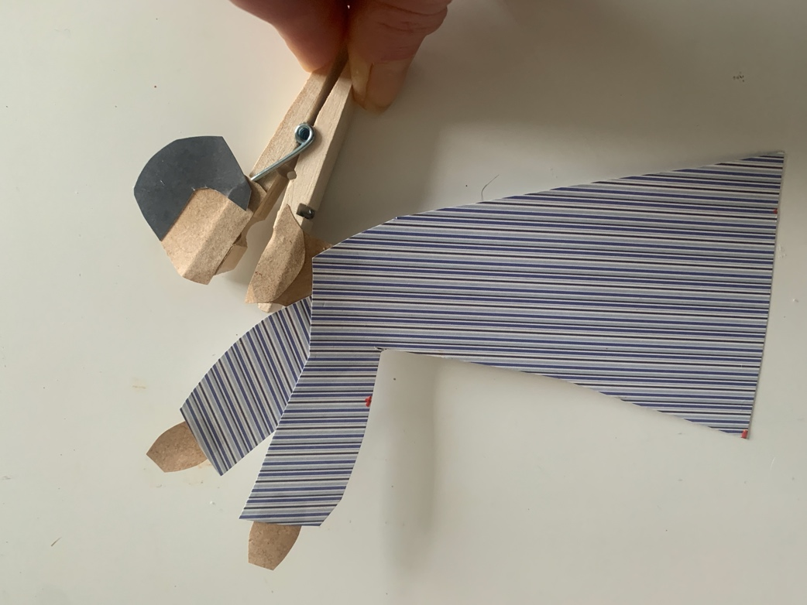
You will need: clothes pegs; glue; scissors; paper; pens; pencils; copies of the puppet template

Peter and John meet a man who is unable to walk and when they pray with him, he is healed and praises God while jumping and walking. This craft opens the puppet’s mouth and children might want to think about what words of praise would have come out! Print out and cut out the puppet pattern. Either colour the pattern in or use it to help you to cut out paper pieces and make your own. Cut along the line dividing the head, and glue each part to a separate leg of the peg (see the photo). Open and close the peg to open and close the mouth of the puppet. What words might the man in the story have been saying?

TOGETHER SESSION FOUR

Flow painting
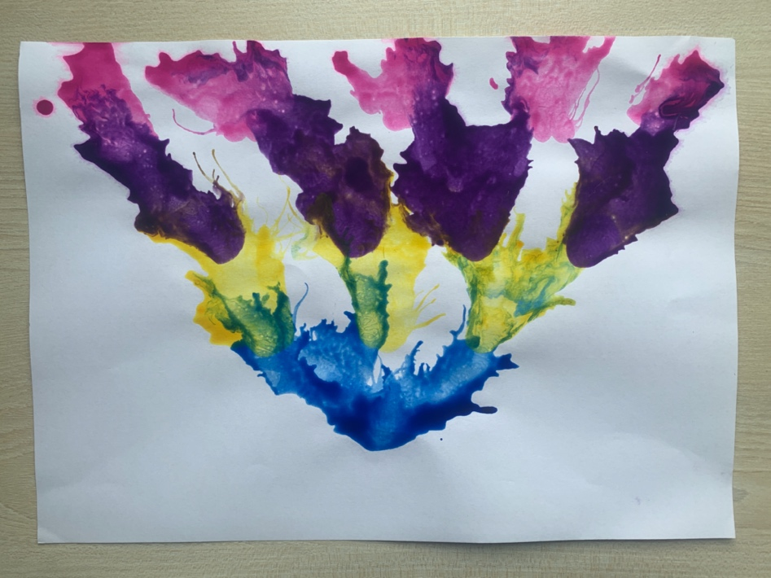
You will need: paint in at least four different colours; containers for paint; water; paintbrushes; straws; plain paper

In Acts 10, Peter tells his listeners that Jesus has told his disciples to go and tell people all about him. This craft reflects the power of the spreading message as one colour spreads to another and the flow is passed on to more. Mix paint with water to make it more able to flow freely. Use paintbrushes to drop blobs of paint onto plain paper in this formation:
[Redraw ‘RTU Craft – Flow painting diagram’ and insert here]
With a straw, blow colour one towards colour two until it connects with all three blobs. Then blow colour two blobs until they connect with all four blobs of colour three. Then do the same with colour three into colour four. You should see some colour mixing happening as the colours flow into each other.

MINA MUNNS
is founder of Flame: Creative Children’s Ministry.

