READY TO USE MENTORING

Helicopter parenting

How much time have you spent discussing the most important relationship in your mentee’s life – the relationship with their parents? Their role (especially if they are absent for any reason), their communication, their example, their mistakes?
One the most amazing questions to ask a child (especially in challenging behaviour) is: “If you were the parent, what would you say to your own child in this situation?” I’ve had so many interesting (and challenging) conversations as a result of this question and seen it impact those young people significantly. What would be even more amazing is if you could have a session with all your young people’s parents and explain all this to them and ask them the same question about their parenting, prompting them to talk to their children about it too.
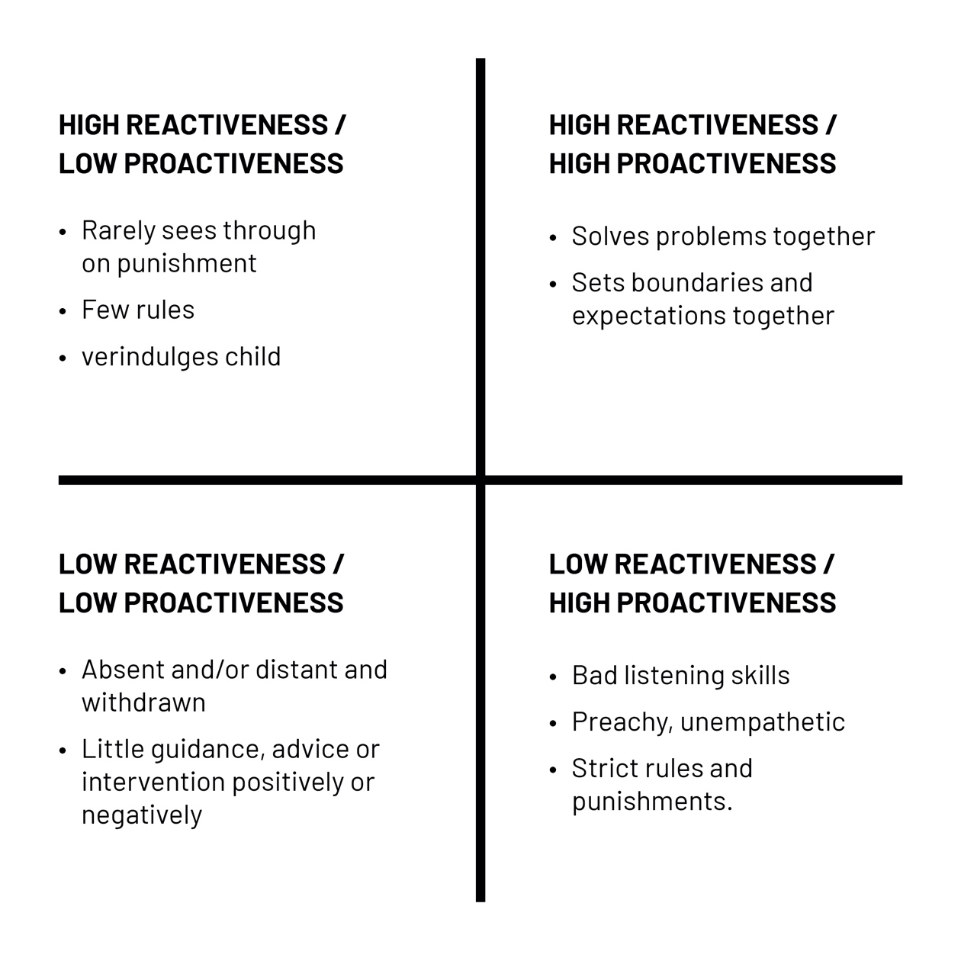
In good and bad parenting, the two main variables are proactiveness and reactiveness. Reactiveness is about their level of engagement to the child’s needs, questions, requests and desires. Low reactiveness would be neglectful; high reactiveness is being a good listener and empathetic. Proactiveness is about how much the parent demands of the child and how much they seek to help or influence things in their life. High proactiveness is signalled by strict rules and punishment and one-way conversations.

With your mentee

Ask your mentee where they would place their parents on this grid. Discuss and also ask them where they think their parents would place themselves on that grid…
What would be the perfect parenting style in their opinion?
Here’s a very quick overview of three different parenting styles:

Helicopter parenting
Excessive levels of involvement and control in the child’s life and learning, albeit out of a desire to help and support. (Always hovering nearby ready to ‘save’ them at any moment.)
Pros: the young person feels supported and that the parent is very present.
Cons: they do not get the opportunity to fail and to learn by themselves. High expectation for success placed on them.
Similar to ‘snowplough parenting’ which seeks to eliminate any threats or obstacles before their child encounters them.

Free-range parenting
The parent allows the young person space and permission to be independent, by teaching them skills but allowing them to encounter the world in unsupervised ways (such as walking home from school on their own).
Pros: This can be empowering and helpful.
Cons: Can leave a grey area where the child may misinterpret this as not caring or being distant.

Lighthouse parenting
Being a constant beacon of light for the child to aid them in navigating growing up, but without interfering too much. They are on hand to send help and to warn of rocky patches ahead and to provide safe harbour when needed.
Pros: Allows the young person to grow in a safe environment.
Cons: Poor communication could result in it looking like neglect or laziness.

JOEL TOOMBS
has an MA in Christian mentoring and wrote the Mentoring and Young People Grove booklet. He is a volunteer youth worker.

