READY TO USE CRAFT

Easter (part one)
Easter this year falls on 9 April, so our Easter sessions are spread across March and April. Use these craft ideas with March’s Together sessions, or combine them with those coming in the April issue to create an Easter activity day.
_______
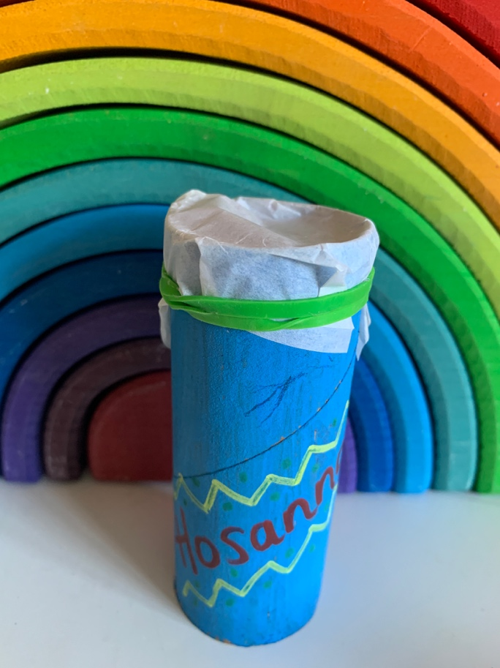

TOGETHER SESSION ONE

Celebration kazoo
You will need: cardboard tubes; felt-tip or paint pens; a skewer; greaseproof paper; elastic bands; scissors
This craft is a way of helping children to engage with the celebratory moment of Jesus entering Jerusalem and will add lots of noise to the usual ‘Hosannas’. Use a skewer to make a hole somewhere near the middle of each cardboard tube. This will make sure that the paper and elastic band won’t come off when children hum through the tube! Decorate the tube with celebratory colours and designs, maybe also the word: ‘Hosanna!’
When you have finished decorating, stretch a piece of greaseproof paper over one end of the tube and secure in place with an elastic band (see photo). Hold the other end of the tube to your mouth and hum an upbeat tune into your kazoo. Imagine being out on the streets welcoming and celebrating the arrival of Jesus.

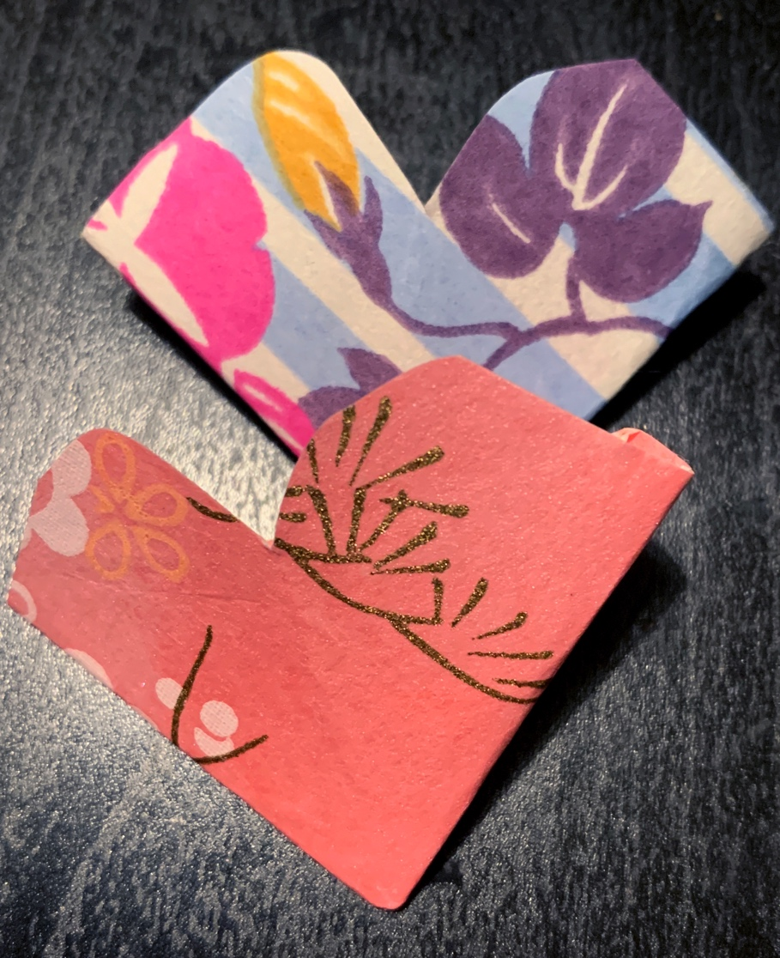
TOGETHER SESSION TWO

Heart bookmarks
You will need: paper squares (10cm x 10cm); instruction sheet
Jesus washes the feet of his disciples as a sign of his love and tells them that they must love each other in the same way that he has loved them. This heart bookmark is a reminder that we need to love each other, following Jesus’ example, and can either be kept for ourselves so that we can see it every time we read a book, or can be given to someone else as a gesture to show that we love them. To make your bookmark, print out and follow the instruction sheet for this craft.

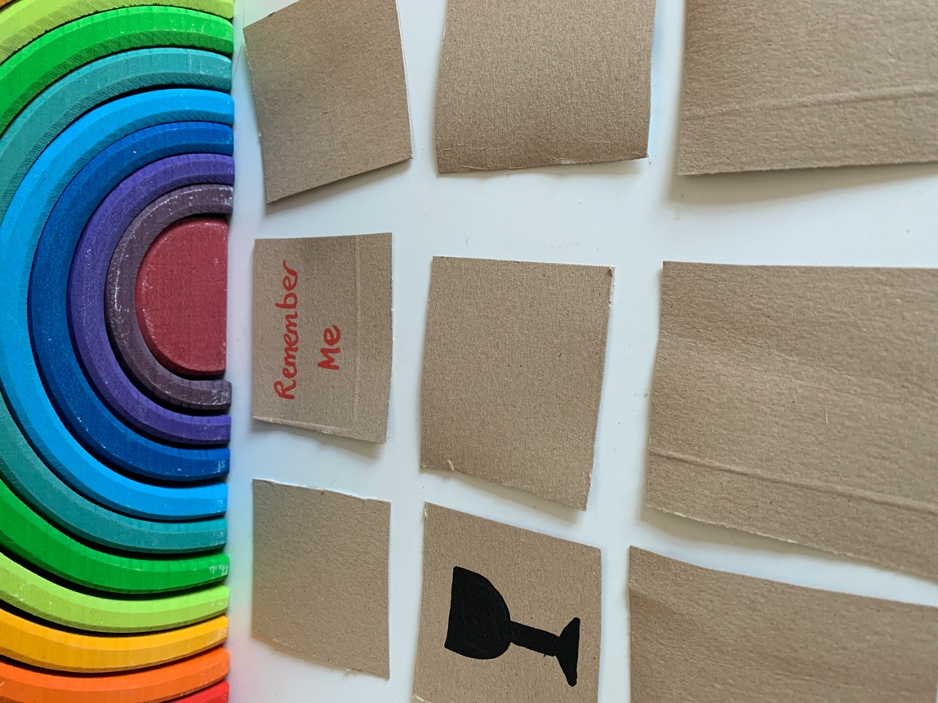
TOGETHER SESSION THREE

Memory game
You will need: cardboard squares (5cm x 5cm); larger pieces of cardboard; felt-tip pens; glue; scissors; plain paper
Give each person a square of cardboard as a stencil and get them to draw and cut out ten squares each from a piece of cardboard. Think of five pictures or words that reflect something of the story of the last supper, eg cup, bread, ‘Remember me’, love, Jesus, disciples, broken, share, body or blood. Choose your first word or picture and draw or write it onto one side of a cardboard square. Take another cardboard square and duplicate what you have done to make a matching pair – blank on one side and with the same picture or word on the other side.
Repeat for your other four words or pictures so that you end up with five different sets of matching pairs. Mix the cards up and turn them all face down. Play with someone else and take it in turns to turn over two of the cards. If you turn over a matching pair, you get to keep them. If you don’t get a matching pair, turn them both face down and let the next person take a turn. The winner is the person with the most matching pairs when all the cards have been taken.

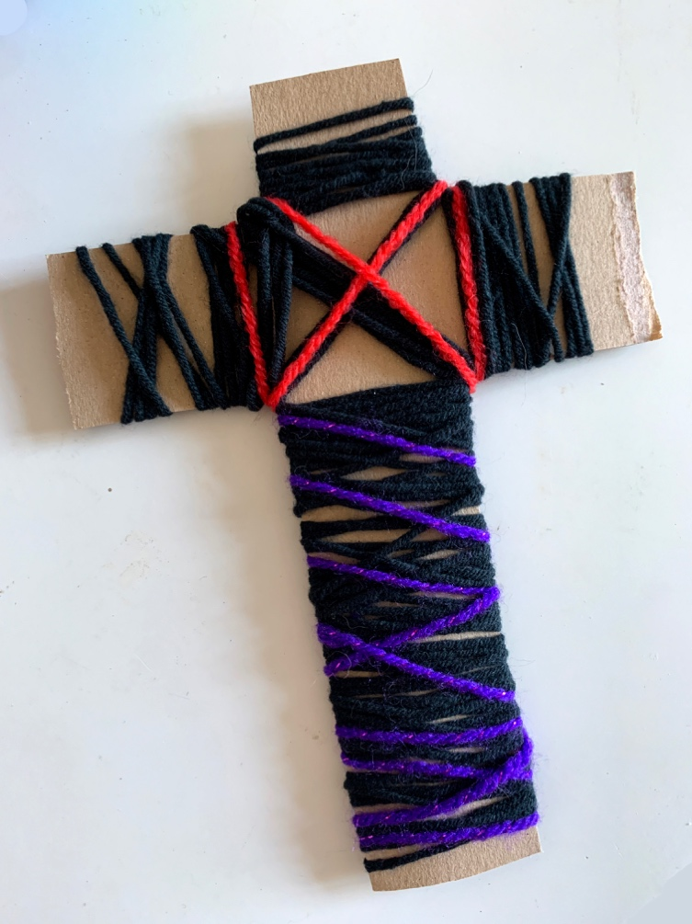
TOGETHER SESSION FOUR

Cardboard cross
You will need: cardboard cross shapes (they need to be quite sturdy); wool; scissors
Cut crosses, roughly 15cm high, out of sturdy cardboard boxes. Cut lengths of wool in various colours. Wrap the wool in various combinations around the cross and use the creating time to talk about the Good Friday story. Where would you be in the story? What do you think is the most important part of the story? Why do Christians think that the cross is important? Some children might want to choose colours that reflect something of the story to their mind, eg red to represent blood, black to represent the darkness.

MINA MUNNS
is founder of Flame: Creative Children’s Ministry.

