READY TO USE CRAFT

Moses
The four stories explored in this month’s Together sessions all focus on Moses and the people of God being rescued from Egypt and heading towards the promised land. Use these craft ideas to explore these themes, either as part of a Together session or at a craft club or event.
_______

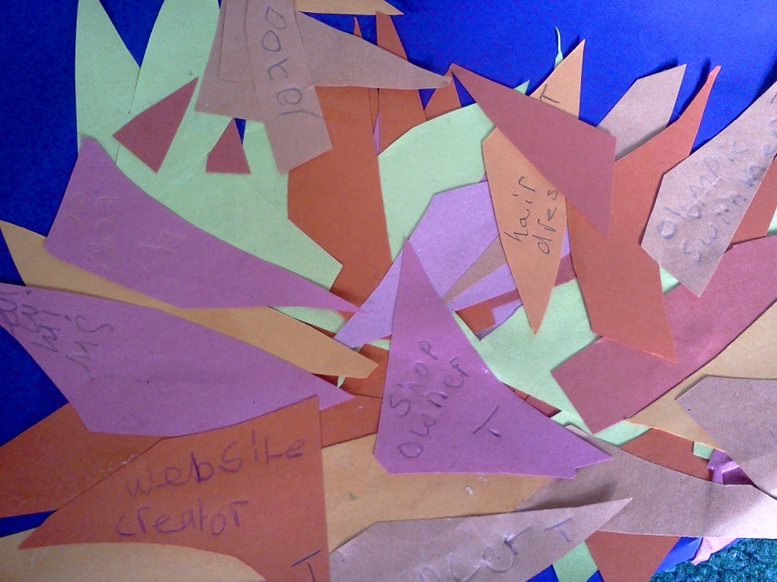
TOGETHER SESSION ONE

Moses
You will need: a large piece of backing paper; orange, red and yellow paper; glue; scissors; pens
Tell the story of Moses and the burning bush and think about the job that God gives Moses to do when he speaks from the flames. Work as a group to make a collage. Cut flame shapes out of the coloured paper and stick them onto the background paper to make a ‘burning bush’. Now ask children to think of the job that they would like to do and to write it on one of the flames. Use this as a starting point to think about God’s plans for our futures and the jobs he might be calling us to do.

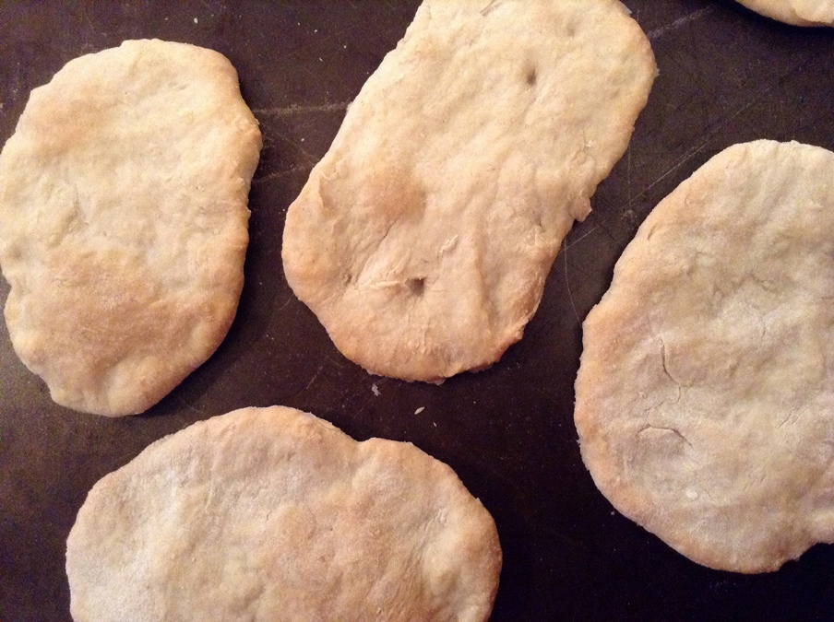
TOGETHER SESSION TWO

Passover
You will need: 175g plain flour; 100ml water; two tablespoons oil; a pinch of salt; baking tray; greaseproof paper
At the time of the first Passover, God tells Moses to make sure that everyone is ready to move quickly. This means that they have to make bread without yeast because there won’t be time to wait for the bread to rise. This food craft shows children how to make unleavened bread similar to what the Israelites may have taken with them.
Pre-heat the oven to 180°C. Mix together the flour, salt, water and oil until a dough is formed. You may need to add a little more flour if the dough is too wet to handle. On a floured surface, take turns in kneading the dough over a period of about five minutes and then separate the dough into six pieces. Use your hands to flatten out each piece of dough into a pitta-bread shape and place on a baking tray lined with greaseproof paper. Bake for 15 to 20 minutes. Take the bread out of the oven and leave to cool. When cooled, share the bread and get the children to reflect on how the story makes them feel and what questions it makes them ask.

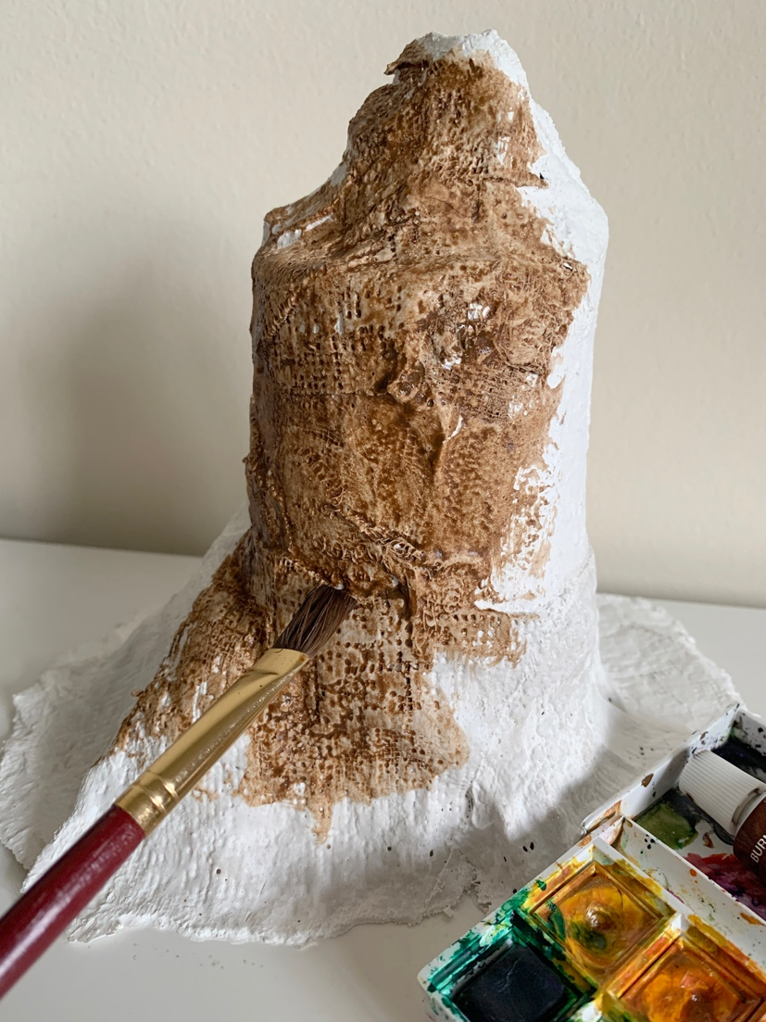
TOGETHER SESSION THREE

Ten Commandments
You will need: large yoghurt pots; tin foil; Mod Roc (plaster of Paris bandages); bowls; water; PVA glue; paint; paintbrushes; hand moisturiser (optional but helpful!); paper or a table covering to protect your working surface
Moses goes up the mountain to meet with God and to be told the Ten Commandments. The mountain is a holy place, a bit like the holy place where Moses meets God in the burning bush. This is a very messy way to make a mountain and to create time to chat about the story.
Mix water and PVA in a bowl: two parts water to one part PVA. This mix will help the paint to stick to the model. Cut up the bandages into short strips. Soak a strip in the PVA-water mix and squeeze out the excess liquid. Place the bandage around the yoghurt pot until the pot is covered. Use foil to make a ‘peak’ and parts of the mountain that stick out. Cover these parts as well until you have made a suitably ‘mountain’-shaped model. Use your hands to smooth out the plaster of Paris and then leave your model to dry.
Put some moisturiser on your hands when you are finished because Mod Roc can make hands feel really dry. When the model is dry, paint it to look more like a mountain. As you paint, use the time to chat about the mountain as a holy place and what it must have been like for both Moses and the people watching from below.

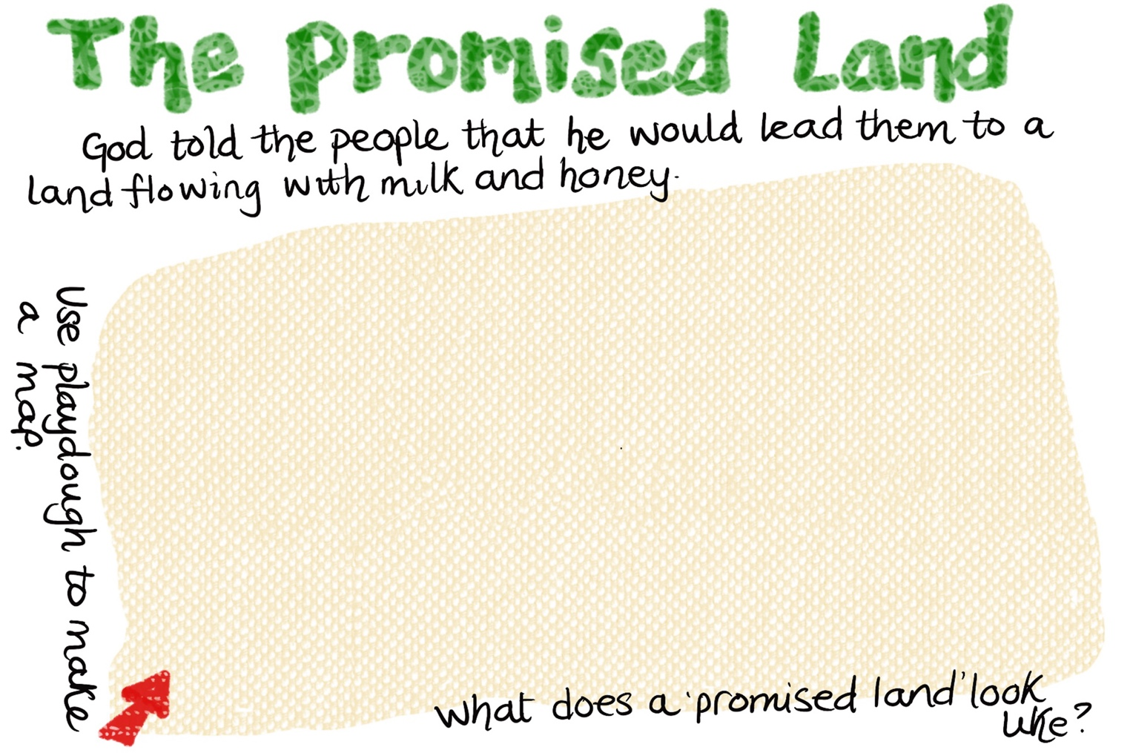
TOGETHER SESSION FOUR

Promised land
You will need: copy of playdough mat; playdough; laminator (optional)
Talk about the special place that God is leading the Israelites to. What do the spies see? What do you think this promised land will be like? Use the playdough to make a map of what you think the place will be like. Save some time so that, if they want to, children can share what they have made.

MINA MUNNS
is founder of Flame: Creative Children’s Ministry.

