READY TO USE CRAFT

Stories from Acts
The four stories explored in this month’s Together sessions all focus on the life of the early Church. Use these craft ideas to explore these themes, either as part of a Together session or at a craft club or event.
_______

TOGETHER SESSION ONE

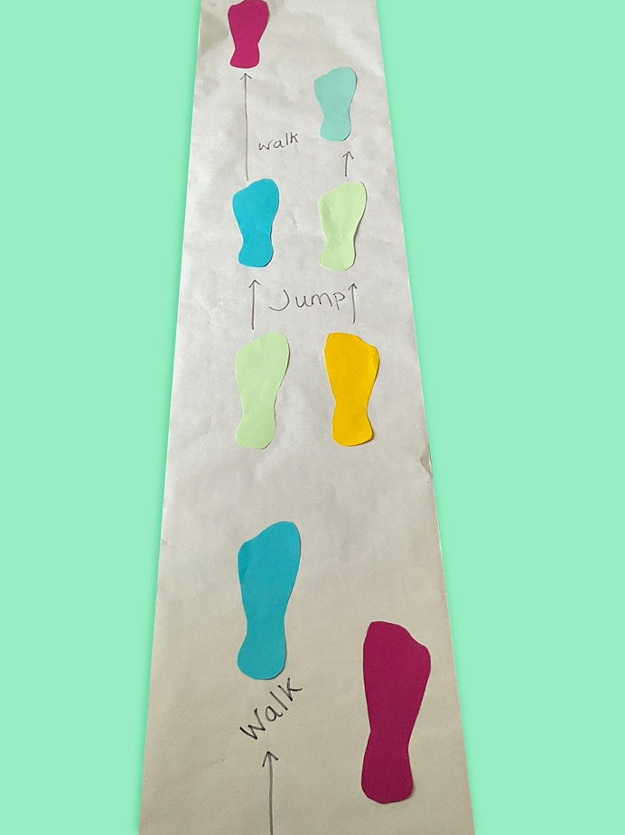
Movement pathway
You will need: coloured paper; scissors; a long roll of paper (lining paper is ideal); glue; felt-tip pens
When the blind man is healed, we hear that he walks and jumps and praises God, getting the attention of the people in the temple courts. This is a collaborative group craft that helps to bring movement to the storytelling.
Ask children to draw around their feet and cut the feet shapes out. You might need multiple sets per child to make this craft work better! Lay out the long roll of paper in a pathway and work together to decide how you will travel across it. Where will you walk and where will you jump? Stick the foot shapes onto the paper accordingly and label them as a reminder.
Take it in turns to walk and jump in the footsteps on the paper. You might want to think of some praise words to write by, or in, the footprints that could be shouted out as children reach that point on the pathway.

TOGETHER SESSION TWO
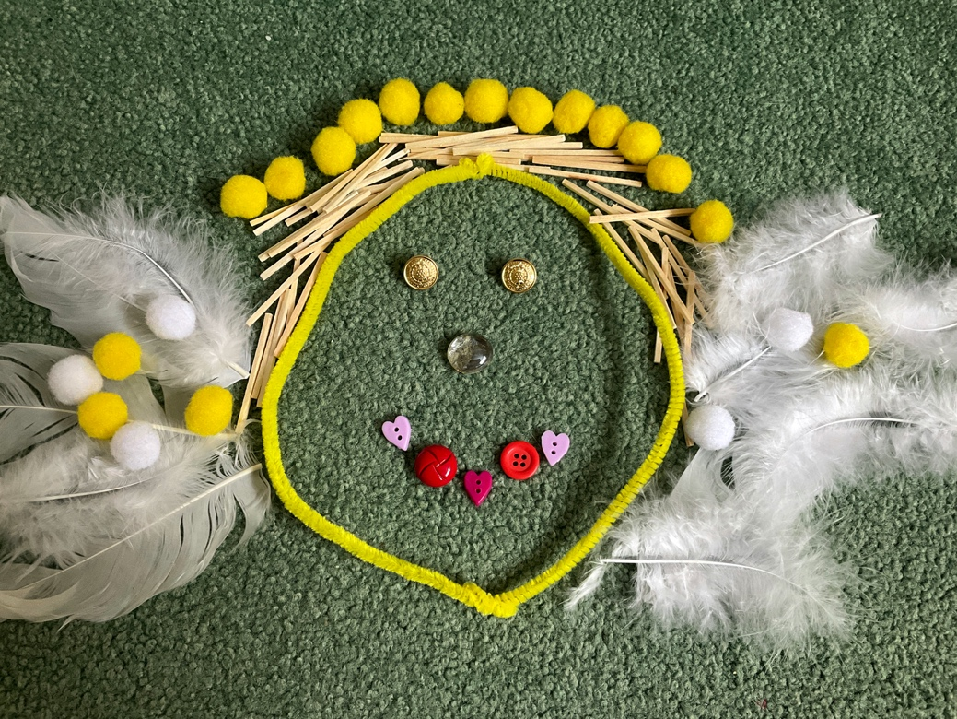

Angel faces
You will need: a collection of different loose pieces, eg feathers, pipe cleaners, buttons, matchsticks, glass pebbles, stones, pompoms
Discuss the description of Stephen in the passage. How does it all feed into the final verse about him appearing to have the “face of an angel” (Acts 6:15)? What would that look like? What can we learn about him?
Use the loose parts to make a picture of Stephen’s face and allow time to share. Why have children chosen particular parts for particular effects? Are the colours used significant? How do the faces relate to what we learn about Stephen?

TOGETHER SESSION THREE
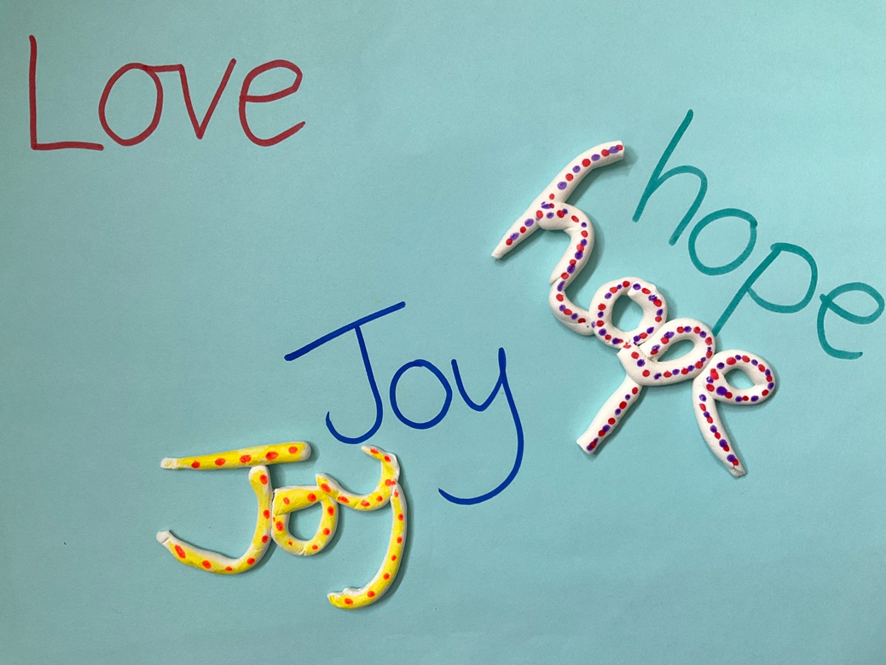

Bringing words to life
You will need: paper; pens; air-drying clay; paint pens
Philip helps the Ethiopian man to understand the words that he is reading in the scriptures, telling him about the good news of Jesus. This craft is about bringing words off the page and making them more meaningful, just as Philip does.
Talk about what the ‘good news’ about Jesus is and get children to write words associated with the good news on a piece of paper. Now use air-drying clay to make tangible words and paint them in colours and patterns that represent that word to whoever is making it. Use the creative time to discuss how these good news words could be lived out in practical ways.

TOGETHER SESSION FOUR
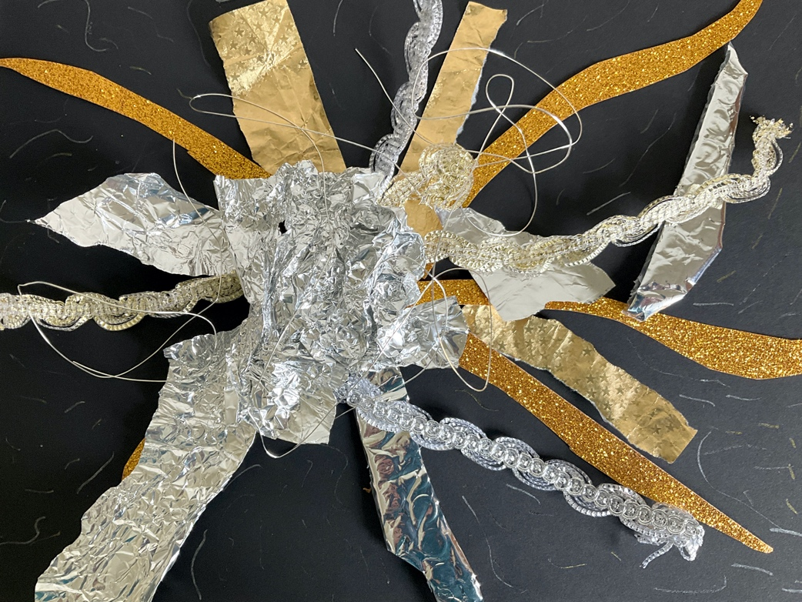

Blazing light collage
You will need: black paper; a collection of glittering or shiny materials, eg gold and silver pens, shiny ribbon, glitter, glitter pens, foil, gold and silver paper, shiny wire
On the road to Damascus, Paul experiences a light from heaven that flashes around him, part of an experience that leads to his conversion.
Use the shiny collage materials to create a sensory picture of that blinding light.
Use the process to open up a conversation about moments of new understanding and experiences that have led to changes of mind about certain matters. Where else do we see God appearing as blazing light in the Bible?

MINA MUNNS
is founder of Flame: Creative Children’s Ministry.

