READY TO USE CRAFT

Jesus teaches the people
This month’s craft ideas are focused on some on some of Jesus’ teaching from Matthew 5-6! Use these craft ideas to explore these themes, either as part of a Together session or at a craft club or event.
_______

TOGETHER SESSION ONE

Blessed are the colourers
You will need: copies of the colouring sheet; pieces of plain paper; felt-tip pens or colouring pencils
The Beatitudes are an amazing set of verses about the upside-down nature of God’s kingdom and the blessings in store for those who might find life difficult in the here and now. This colouring sheet explores just one of the verses: blessed are the peacemakers. As you colour in the sheet, chat about the other promises that Jesus makes in this passage. Children might then want to choose one of the Beatitudes and create their own colouring sheet based on it.

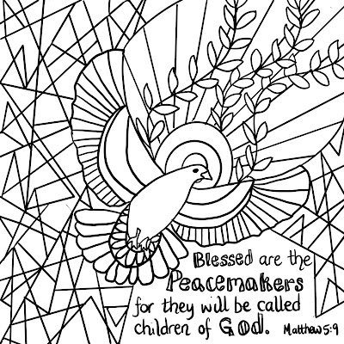
TOGETHER SESSION TWO
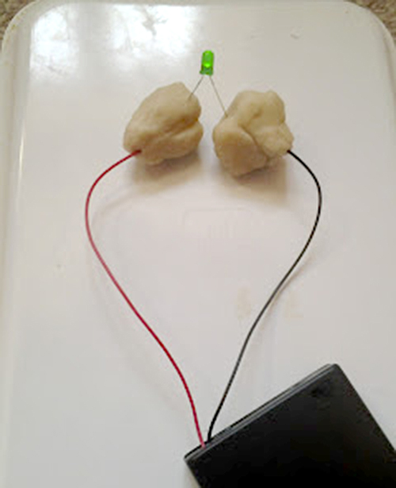

Salt and light
You will need: playdough (homemade is best as it has a high salt content); dough made with flour and sugar (find instructions for both kinds of dough here); food colouring; battery pack with batteries; LED lights
Make two balls of the sugar dough and colour them with the food colouring. Insert one wire of the battery pack into each ball of dough. Connect one leg of the LED light to each ball (make sure that the longer + leg goes to the ball connected to the + wire side of the battery pack). Switch the battery pack on and nothing will happen to the LED light as the sugar dough doesn’t conduct the electricity. Disconnect the battery pack and light from the sugar dough and repeat the process, this time using the salt dough. This time, when you switch the battery pack on, the light will come on! This is a great visual to demonstrate that if we are like the salt in the playdough, we will conduct the light of God’s love so that everyone around can see it.

TOGETHER SESSION THREE

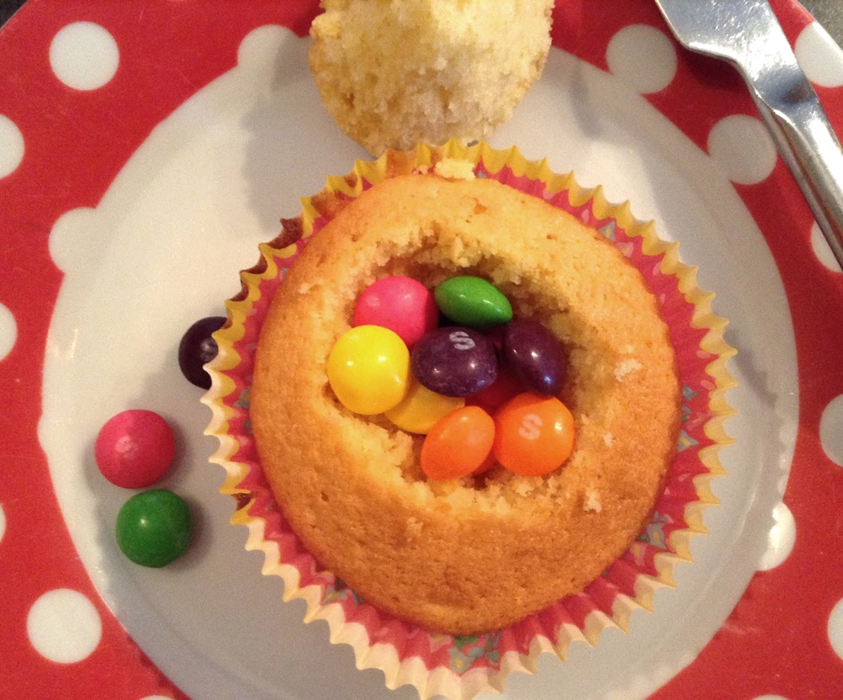

Surprise cakes
You will need: undecorated cupcakes; a knife or spoon; small sweets (eg Skittles or mini-Smarties); buttercream icing
This passage talks about giving generously in a secret and hidden way, and these cakes carry hidden treasure! Cut a hole in the top of a cupcake with a spoon or a knife and reserve the ‘top’ of cake you have cut out. Make a well in the cake, big enough to hold some small sweets. When you have put the sweets inside, replace the cake top and cover with buttercream icing so that no one can see the join. Give the cake to someone and watch their surprise when they find the hidden gift of sweets. You may need to give a warning to eat carefully!

TOGETHER SESSION FOUR

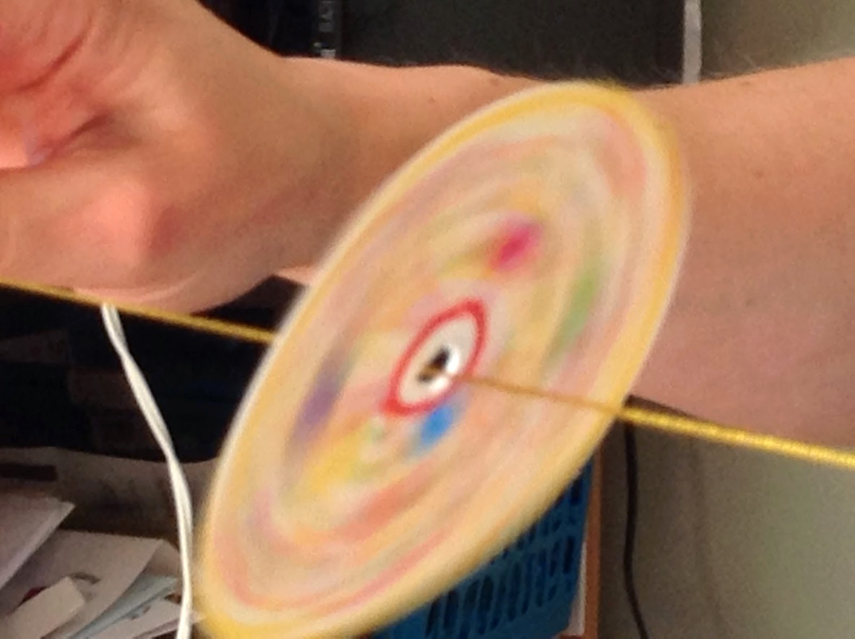

Worry spinner
You will need: circles of white card; felt-tip pens and colouring pencils; coloured dot stickers; string
Jesus tells us not to worry but, in reality, that’s quite difficult for a lot of us. Sometimes it is incredibly helpful to symbolically give over our worries to God – to let go and trust them to him. This is a colourful and kinesthetic way to help children to do this.
Take a card circle and stick a pen or pencil through the middle of the circle to make a hole.
Think about the things you are worried about and write or draw them on the circle. You might alternatively want to take a coloured sticker to represent something you are worried about and use the stickers to decorate the card. Make sure to use lots of colour for the best effect in the next step.
When you have finished decorating, thread a string through the hole in the circle and hold tightly to each end. Give a wrist flick and the circle should start to spin on the string. The colour worries will all blend together as the circle spins and children can picture leaving those worries with God. This activity can be repeated for future worries – just add more dots to the circle!

MINA MUNNS
is founder of Flame: Creative Children’s Ministry.

