READY TO USE CRAFT

God is with me through the tough times
The passages this month are all about knowing how God is with us, even when times are tough. You might not think that such passages lend themselves to craft activities, but these ideas are ideal for giving children time and space to process difficult thoughts, as well as providing focal points for prayer.
_______

TOGETHER SESSION ONE
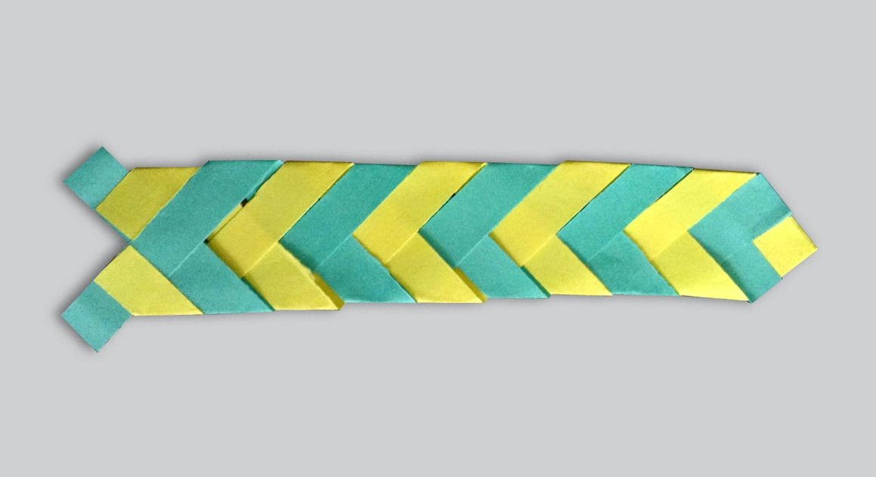

Paper braid
You will need: four strips of coloured paper 15cm x 1cm (two of one colour and two of another); glue; a copy of the instruction sheet
The story of Ruth and her mother-in-law, Naomi, is a great way to explore themes of welcoming new people into a family or community and thinking about who takes care of us and who we take care of. Naomi is a strong woman who inspires faithfulness in Ruth, who chooses to stay with her. This craft helps to pick up on the theme of unity that comes from faithfulness to each other and to God. Follow the instructions to make the paper braid. Choose one colour to represent Ruth and one colour for Naomi. As you create, chat about why Ruth may have wanted to stay with Naomi. Who are our lives joined to and why?

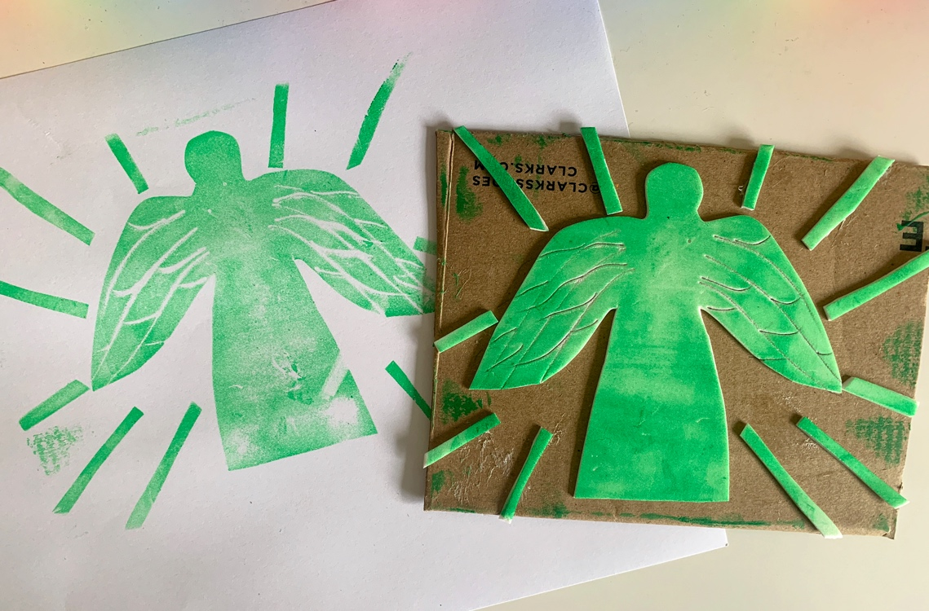
TOGETHER SESSION TWO

Story stamp
You will need: craft foam; stiff cardboard; scissors; glue; paint or ink; paintbrushes or roller and tray; paper
After listening to the story, get children to think about the part they like the most or the part that they think is most important. What picture could they create to illustrate it? An angel? Elijah in the cave? Bread? Footsteps for Elijah’s journey? Make a picture by cutting out craft foam and gluing it to a square or rectangle of cardboard. The foam will stick out from the cardboard base like a lino stamp that you can make a print with. Carefully cover the foam with paint, or apply paint or ink with a roller. Turn the picture paint down and apply pressure evenly. Lift up the stamp and see the print you have created!

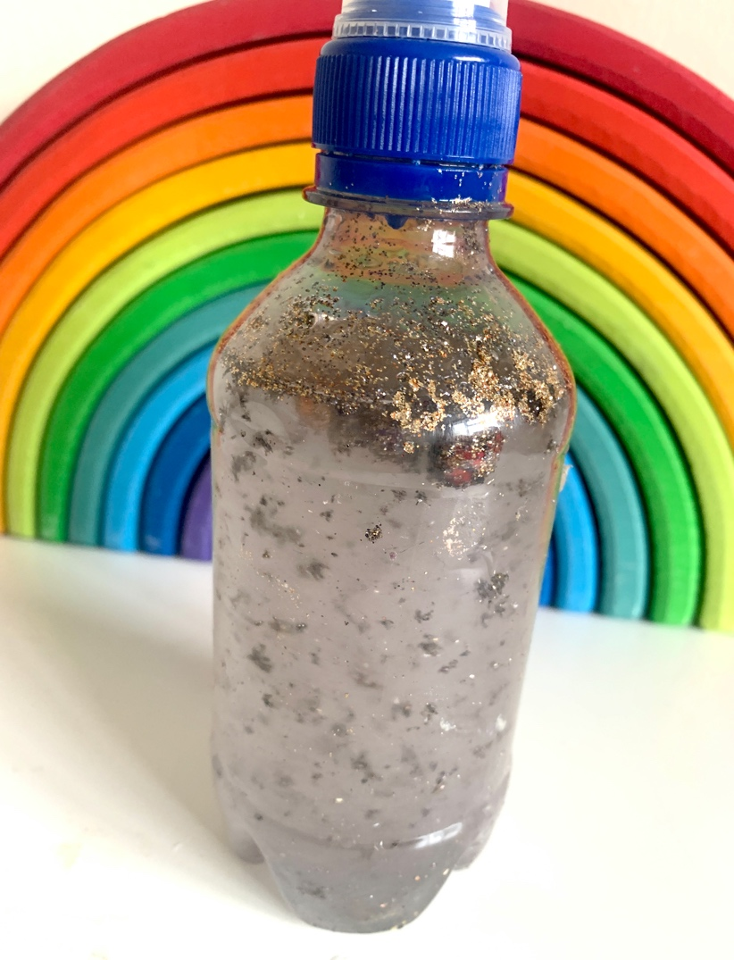
TOGETHER SESSION THREE

Sensory bottles
You will need: clear bottles with lids (water bottles with labels taken off are ideal); glitter; small beads; any small objects that will fit into the bottle eg paperclips; water; food colouring; superglue or sticky tape (optional)
The passage from Job is filled with the turmoil of what is going round in his mind: “I have no rest, but only turmoil.” This craft helps to create a sense of confusion and turmoil that will eventually settle, similar to the way in which Job’s life is eventually brought back into order through God. Fill the bottle with water but leave a little space for the things you will add to the mix. Add a spoonful of glitter, some beads and any other small waterproof items that will add to the confusion when the bottle is shaken. You might also want to add a little food colouring to the water. Securely fasten the lid onto the bottle and, if you will be using the bottle with younger children, make sure that the top is taped or superglued down. Shake the bottle and watch the objects and glitter swirl around in ‘turmoil’ before they come to an eventual rest.
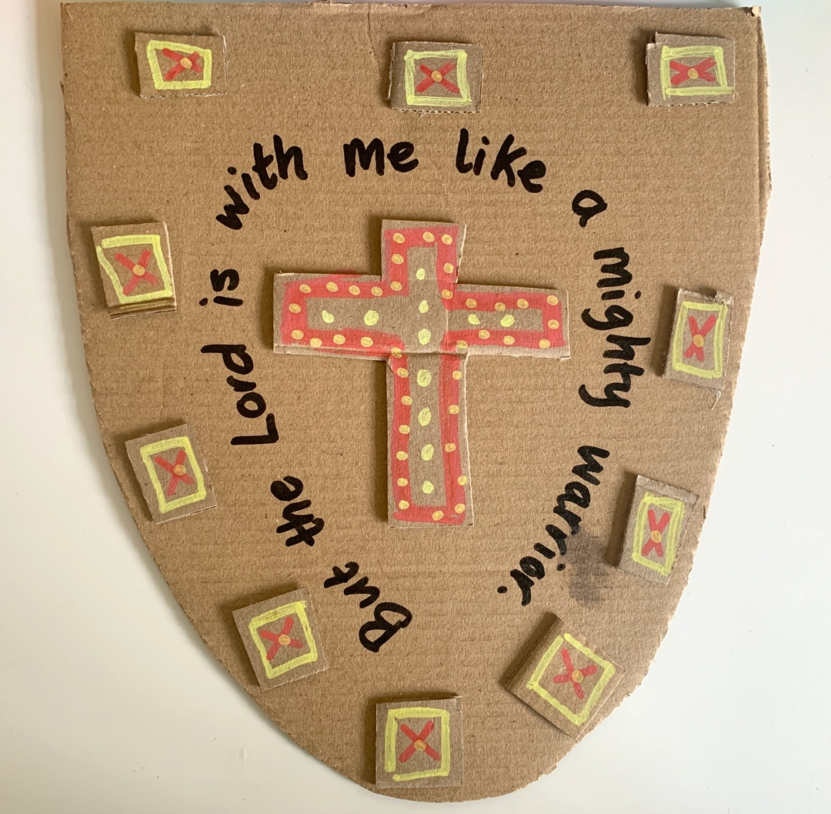
TOGETHER SESSION FOUR

Shields
You will need: cardboard boxes; scissors; glue; paint (optional); strong tape such as gaffer tape
In this passage, Jeremiah goes between bemoaning his fate and complaining about what God has let him come to, to praising God because he rescues and is with him like a ‘mighty warrior’, back to moaning again. Through it all, though, there is this sense that God is there and can be relied on somehow. This craft is a reminder of God’s presence and protection as a ‘mighty warrior’. Cut out a shield shape from the cardboard and either cut and glue or paint shapes on the shield to represent God’s protection. You might also want to attach a cardboard strap on the reverse of the shield so that it can be held, using strong tape.

MINA MUNNS
is founder of Flame: Creative Children’s Ministry.

