READY TO USE CRAFT

Parables from Matthew
This month we explore four parables from the Gospel of Matthew, where Jesus teaches about the kingdom of heaven. Use these activities alongside a Together session or as part of a craft afternoon. You could give them out to parents and carers, with a pack of resources, so that they can do them at home.
_______

TOGETHER SESSION ONE

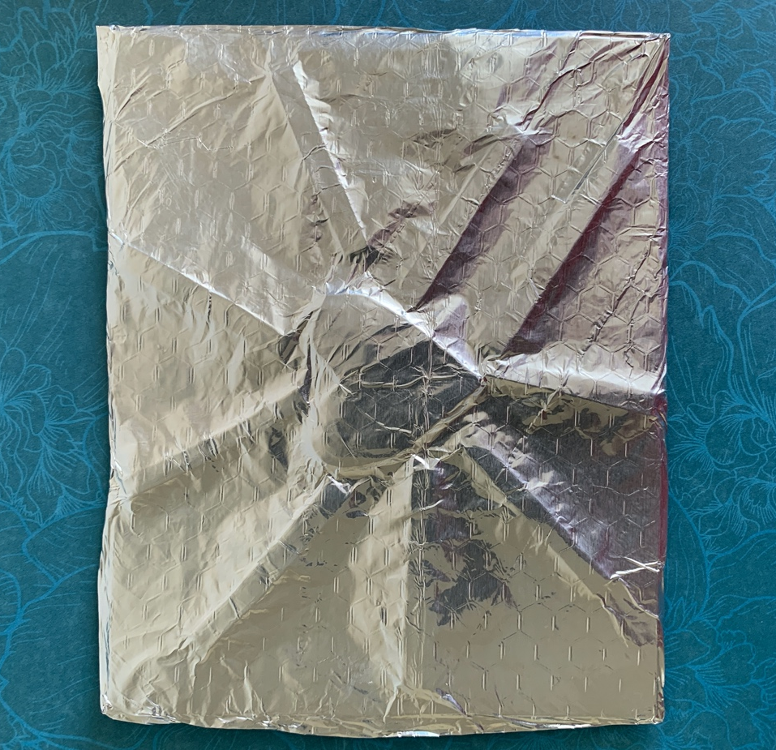

Precious pictures
You will need: thick cardboard; string; glue; scissors; foil
This parable is about the value of the kingdom of heaven and this craft reflects something very precious.
Use a piece of cardboard as a base to create a picture of something valuable and special. You are only looking for outlines of a picture and need to create something that is raised from the card base. Cut-up pieces of thick card are good for this, as is thicker string and wool, which can be stuck down on the base. Everyone will have their own idea of what is precious and what that looks like. Cut a piece of foil at least twice the size of the base card and wrap the picture in it, making sure that any foil edges are tucked at the back. Gently press down over the raised parts of the picture so that it looks as if it has been created from silver, to reflect its value. Compare the kingdom of heaven to what we think is precious in our own experience.

TOGETHER SESSION TWO

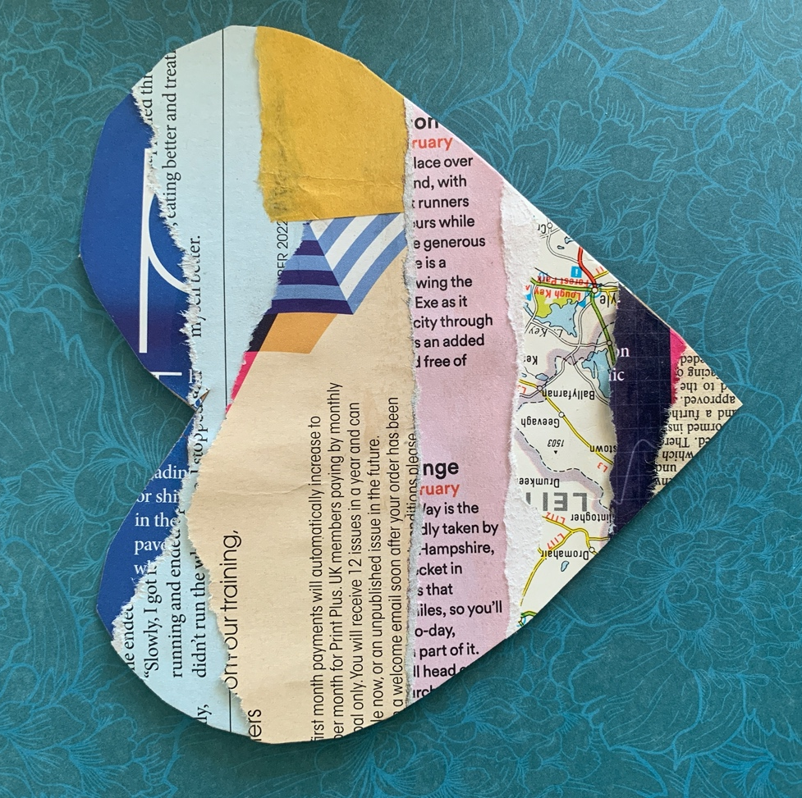

Forgiving hearts
You will need: card; patterned paper or old magazines; glue; scissors
In the parable of the unforgiving servant, Jesus is asked how many times we should forgive someone, and he tells a story about how we should forgive people from our heart. What does a forgiving heart look like? How can you show that there is room to forgive someone seventy times seven times?
Cut or tear and stick paper to decorate a heart shape. The different patterns and the mixture of words and images you can make with magazine pages helps to create a sense of variety and can be a real spur to imagination. When the heart shape is filled, trim off any edges. As you create, use the time to think about what forgiveness is, how it feels and why it might be difficult sometimes.

TOGETHER SESSION THREE

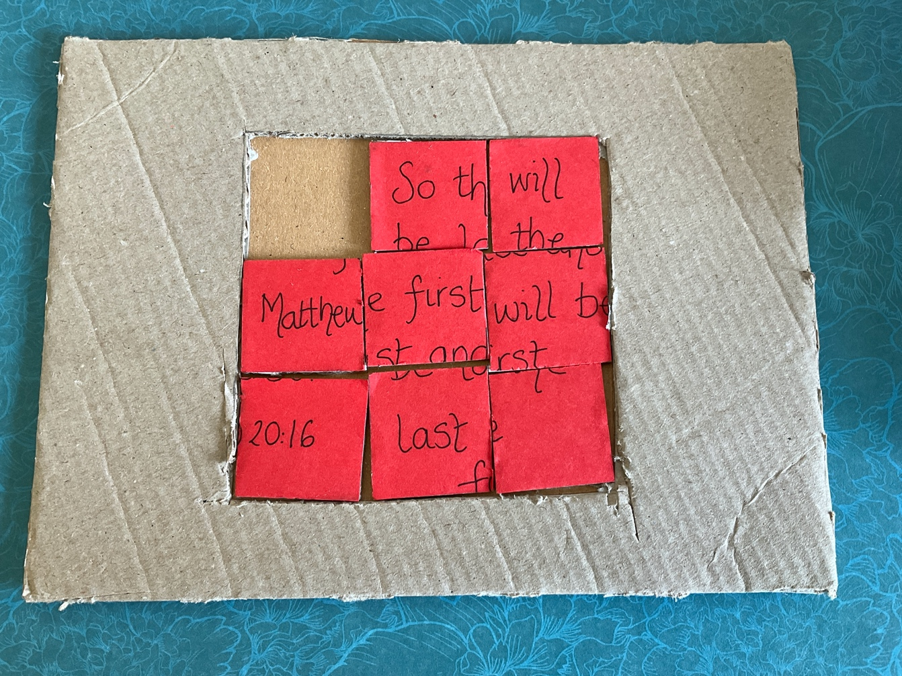

Puzzle mix up
You will need: photo instruction sheet; two cardboard rectangles roughly A5 size, either both from thick cardboard boxes or one thick and one thin piece of cardboard; one 9cm x 9cm piece of paper; scissors; pencil; pens; ruler; glue
The parable of the workers in the vineyard is about God’s kingdom mixing up the way we expect things to be done on earth. This craft plays with that ‘mixing up’ theme as well as drawing on the verse that Jesus ends the story with, ‘So the last will be first and the first will be last.’
This craft it a little bit complicated, so there is a sheet with photo instructions on it to help you out. Print off the sheet, follow the directions and, when you have made your puzzle, think about why God might want to mix up our expectations!

TOGETHER SESSION FOUR

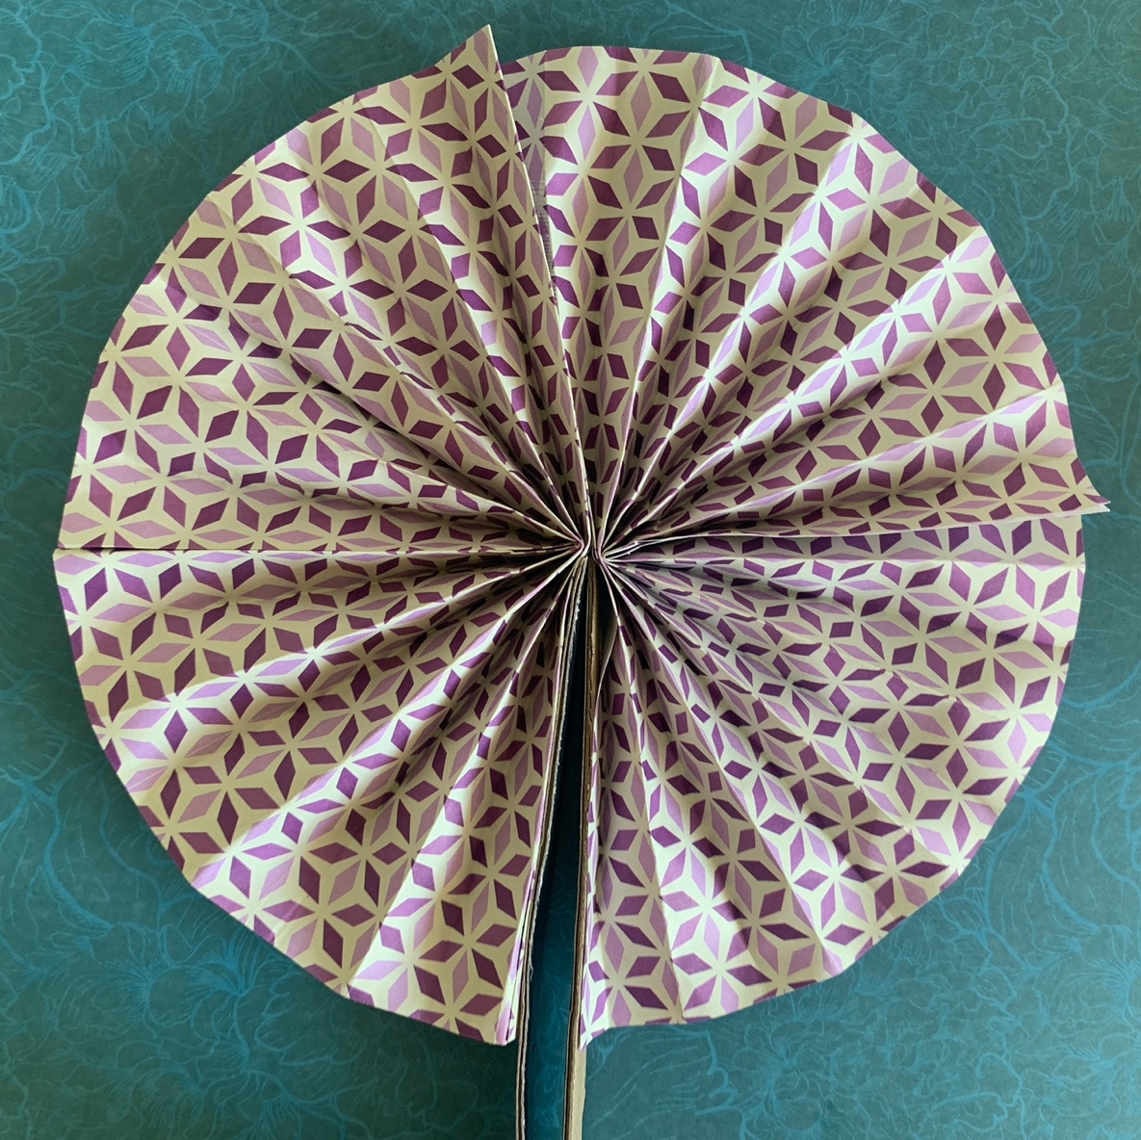

Talent fan
You will need: instruction sheet; two pieces of paper 15cm x 15cm; glue; two large lolly sticks or two thick cardboard strips
This craft reflects the multiplication of the talents in the story and the fact that those who have will be given more, by opening up and fanning out the paper.
Print off the sheet of instructions and follow them to make your fan. Children can choose colours and patterns to reflect their own character or the talents that they think they have. Alternatively, they can use plain paper and write and draw on it the gifts they feel that God has given them and then use that paper to make the fan. When you have made the fans, think about how you can open out and use the gifts that God has given you so that you can spread them further.

MINA MUNNS
is founder of Flame: Creative Children’s Ministry.

