READY TO USE CRAFT

Joshua
This month’s craft ideas are focused on the story of Joshua and the people of God, as they approach and cross into the promised land. Use these craft ideas to explore these themes, either as part of a Together session or at a craft club or event.
_______
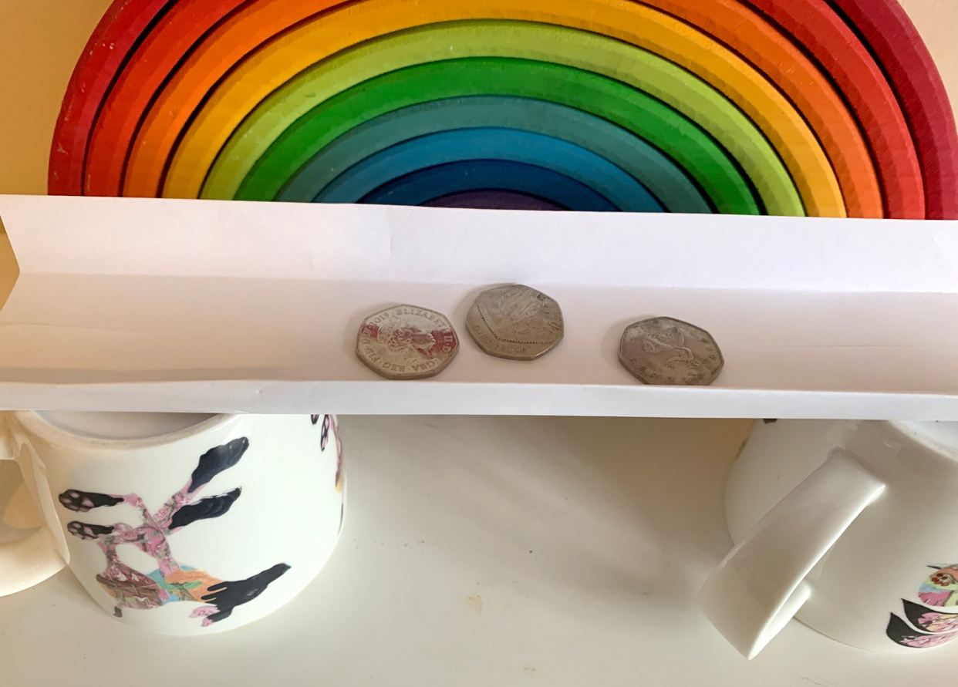

TOGETHER SESSION ONE

Strength test
You will need: A4 paper; mugs; coins
Split children into pairs or small teams and ask them to use the paper to build a bridge between two mugs. The winner will be the team with the strongest bridge – the bridge that can hold the most coins without collapsing. Teams can’t use sticky tape, the mugs must be at least the width of another mug apart and a maximum of two pieces of paper can be used by each team. How can you help to strengthen the bridge?
Chat about what God tells Joshua: “Be strong and courageous.” Why does Joshua have to be strong and courageous? When do we need to be? What does God say about how he will help?

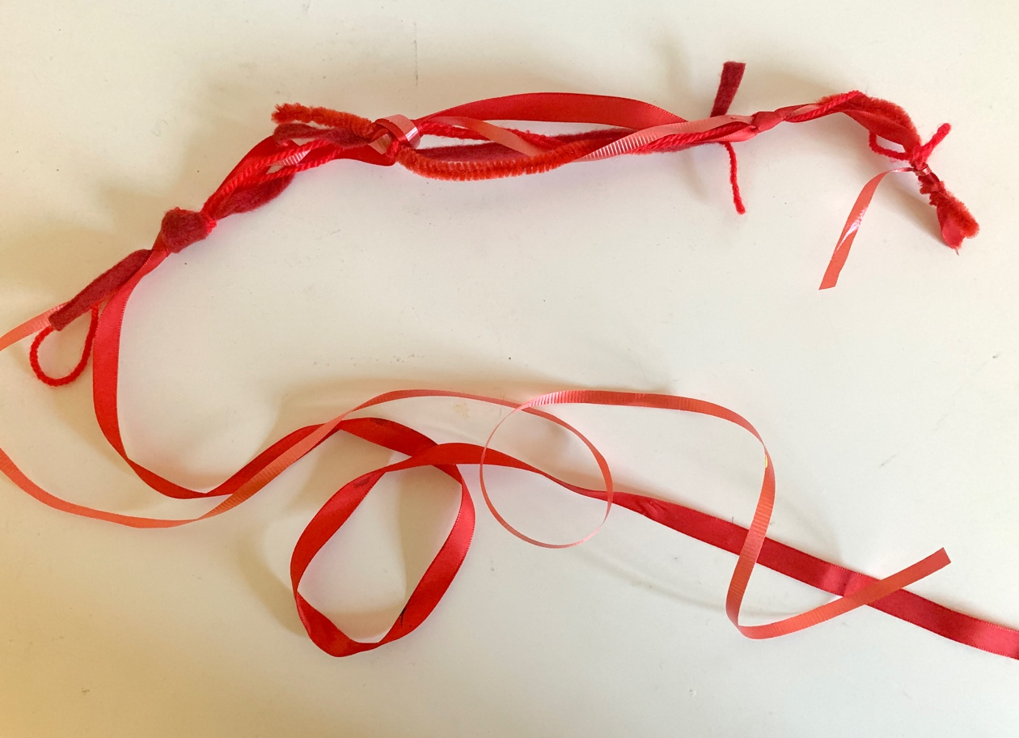

TOGETHER SESSION TWO

The red cord
You will need: red fabric; ribbon; cord; felt; wool; scissors; pipe cleaners
The spies tell Rahab that when they return, if she hangs a red cord from her window, she and her family will be kept safe. Choose from the red materials and combine them to make a long ‘cord’. You might tie or weave them together in any combination. As you are making the cords, chat about what it means to be safe and what makes us feel safe. Why did the spies want to help Rahab stay safe? Why did she want help to keep them safe? How does God make us feel safe?

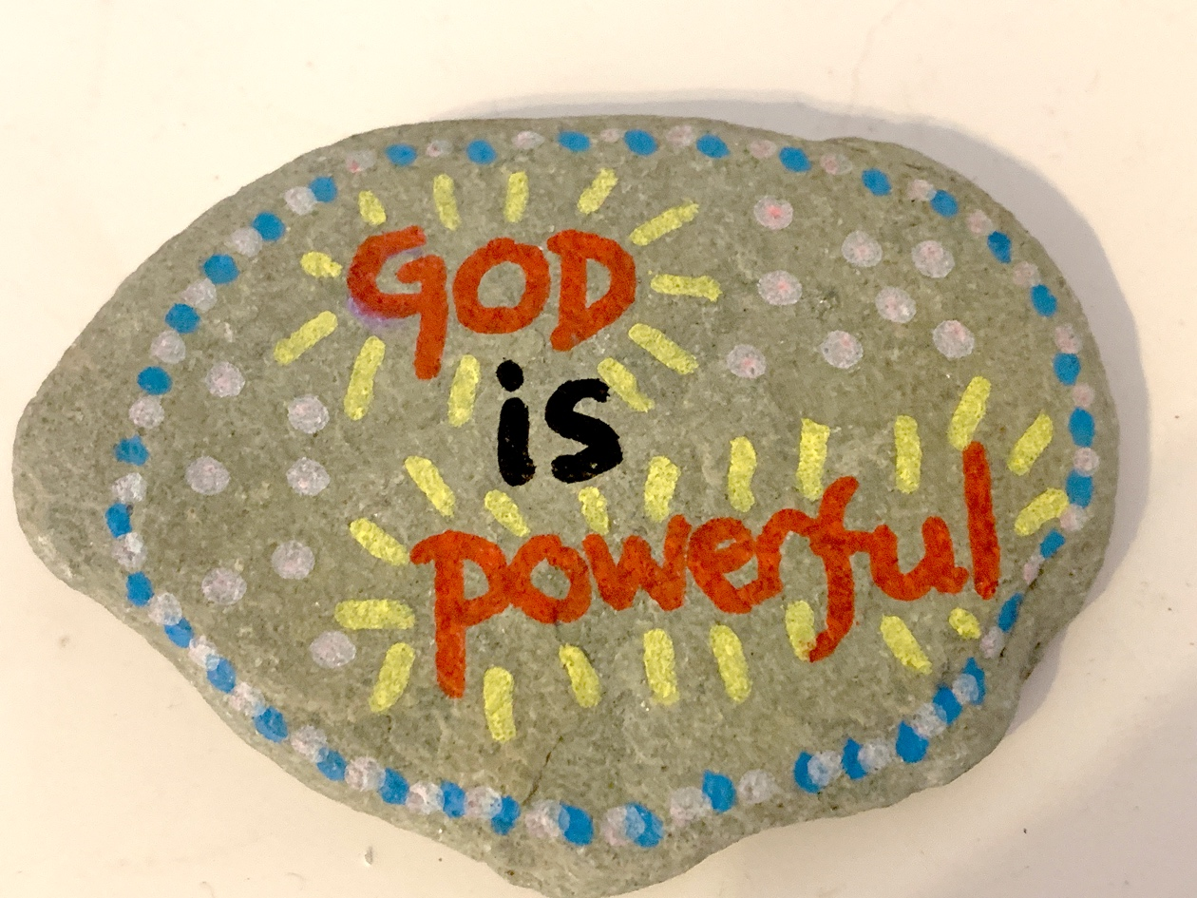
TOGETHER SESSION THREE

Marker stones
You will need: stones big enough to write or draw on; paint pens or paint; clear varnish (optional)
When the Israelites have crossed the miraculously parted river Jordan, Joshua tells the people to take a stone for each tribe and to set it up in their camp as a sign for the future of God’s power in parting the river so that they could cross over. Use the paint or paint pens to decorate the stone with a picture or words that remind children of the story or God’s power to do amazing things. If you wish, when the paint is dry, varnish the stones for greater longevity of the picture or message. Keep the stone somewhere you will see it as a regular reminder of the miraculous things that God can do.

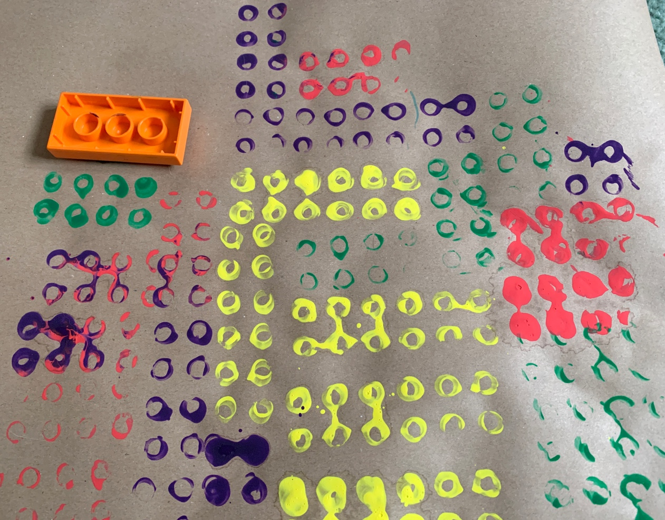
TOGETHER SESSION FOUR

Wall paintings
You will need: paper; paint; Duplo blocks and paint palettes or Lego bricks and ink stamping pads
The story of the walls of Jericho is another example of God’s miraculous power. It’s also a story about God’s people trusting in what he tells them to do. This craft can be done as a group effort if you want to emphasise the idea of the Israelites working together. Spread paint onto the paint palettes and dip the bricks face down into the paint. Then use the paint-dipped bricks to print the bricks of a ‘wall’ onto the paper. You can make individual paintings or work together as a group on a bigger piece of paper. If you are using Lego bricks, do the same but with the ink pads instead of paint. This option will work better on a smaller scale. While you create, use the time to chat about what it might be like to trust God to do something you can’t do yourselves, just as the Israelites needed God to break down the walls of Jericho. How do you think they felt when the people saw the walls fall? When you have finished, have a go at breaking apart the walls you have made!

MINA MUNNS
is founder of Flame: Creative Children’s Ministry.

