Story for home
Divide the group into two. Have one half play the owner and the other half play the workers. You can play the foreman.

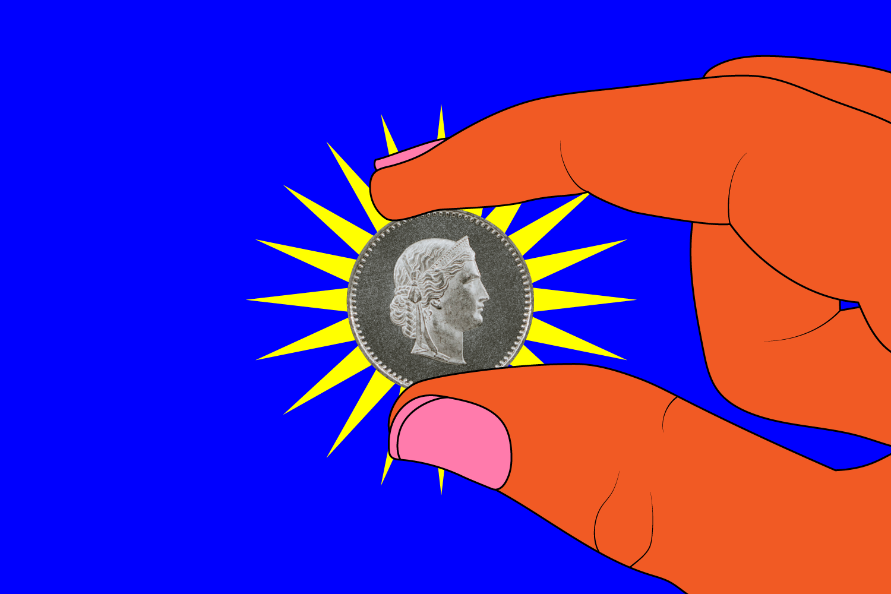

A shiny silver coin

It was very early in the morning. First thing. A man who owned a vineyard went into town looking for workers. He came to the marketplace and made the following announcement:
“This is what I say. Point to mouth.
And this is what I’ll pay. Hold out hand.
A shiny silver coin! Pretend to hold coin between fingers.
If you work for me today.” Point out as if to ‘you’.

Several workers agreed to his terms. And they replied:
“We hear just what you say. Hand to mouth.
We know just what you’ll pay. Hold out hand.
A shiny silver coin! Pretend to hold coin between fingers.
If we work for you today.” Point out as if to ‘you’.

Off they went to work in the vineyard. But, later that morning, at nine o’clock, the man needed more workers. So back he went to the marketplace. And again, he announced:
“This is what I say. Point to mouth.
And this is what I’ll pay. Hold out hand.
A shiny silver coin! Pretend to hold coin between fingers.
If you work for me today.” Point out as if to ‘you’.

These men agreed to work in the vineyard, as well. And they replied:
“We hear just what you say. Hand to mouth.
We know just what you’ll pay. Hold out hand.
A shiny silver coin! Pretend to hold coin between fingers.
If we work for you today.” Point out as if to ‘you’.

As the day wore in, the man realised that he still didn’t have enough workers. So, at noon, and then at three o’clock, the owner of the vineyard went back into town. And when he found some men just standing around, he said:
“This is what I say. Point to mouth.
And this is what I’ll pay. Hold out hand.
A shiny silver coin! Pretend to hold coin between fingers.
If you work for me today.” Point out as if to ‘you’.

Those men agreed to work in the vineyard, too. And they replied:
“We hear just what you say. Hand to mouth.
We know just what you’ll pay. Hold out hand.
A shiny silver coin! Pretend to hold coin between fingers.
If we work for you today.” Point out as if to ‘you’.

Finally, at five o’clock, when the owner went to the marketplace, he found even more men just standing around.
“Why aren’t you working?” He asked.
“Because no one has hired us,” the replied.
And so the owner told them:
“This is what I say. Point to mouth.
And this is what I’ll pay. Hold out hand.
A shiny silver coin! Pretend to hold coin between fingers.
If you work for me today.” Point out as if to ‘you’.

The men agreed and, like the others, they replied:
“We hear just what you say. Hand to mouth.
We know just what you’ll pay. Hold out hand.
A shiny silver coin! Pretend to hold coin between fingers.
If we work for you today.” Point out as if to ‘you’.

When the day’s work was done, the owner of the vineyard told his foreman to pay the workers their wages, starting with those who had been hired last. So the foreman announced:
“Come without delay! Beckon with hand.
Come and take your pay! Hold out hand.
A shiny silver coin! Pretend to hold coin between fingers.
For the work you did today.” Point out as if to ‘you’.

Those who started work at five o’clock received a silver coin. As did those who started work at three o’clock and twelve o’clock and nine o’clock. When those who started work at the very start of the morning came for their money, they assumed they would receive much more. But they were given exactly the same pay as all the others. One shiny silver coin. So off they went to the owner, to complain.
“This is not fair we say! Shrug shoulders and hold hands out to the side.
We sweated the whole day, Wipe hand across forehead.
But those who showed up late, Point to wrist.
Were given the same pay!” Pretend to hold coin between fingers.

“Friends,” replied the owner replied. “I’m not being unfair, at all. Surely, you remember my offer:
“This is what I say. Point to mouth.
And this is what I’ll pay. Hold out hand.
A shiny silver coin! Pretend to hold coin between fingers.
If you work for me today.” Point out as if to ‘you’.

“And, just as surely, you must remember what you agreed to:
“We hear just what you say. Hand to mouth.
We know just what you’ll pay. Hold out hand.
A shiny silver coin! Pretend to hold coin between fingers.
If we work for you today.” Point out as if to ‘you’.

“I have paid you what I promised to pay you,” said the owner. “Take your money and go. And if I choose to be generous to the others, well, it’s my money and I am free to do with it what I please. For the last shall be first and the first last.”

“And that”, said Jesus, “is what the kingdom of heaven is like!”

BOB HARTMAN
is an author and performance storyteller, who has spent many years writing and telling stories.

