READY TO USE CRAFT

All about Jesus
The four stories explored in this month’s Together sessions all focus on Jesus and his ministry, taking in his teaching, miracles and storytelling. Use these craft ideas to explore these themes, either as part of a Together session or at a craft club or event.
_______

TOGETHER SESSION ONE
Jesus heals
You will need: a short length of cardboard tube per child, or roll of tape; sticky tape; scissors; straws; paper
This story is about the release of healing Jesus gives to the man who is lowered through the roof – not just the healing of forgiveness, but also the physical healing of being able to get up and walk. This craft is all about that forward movement.
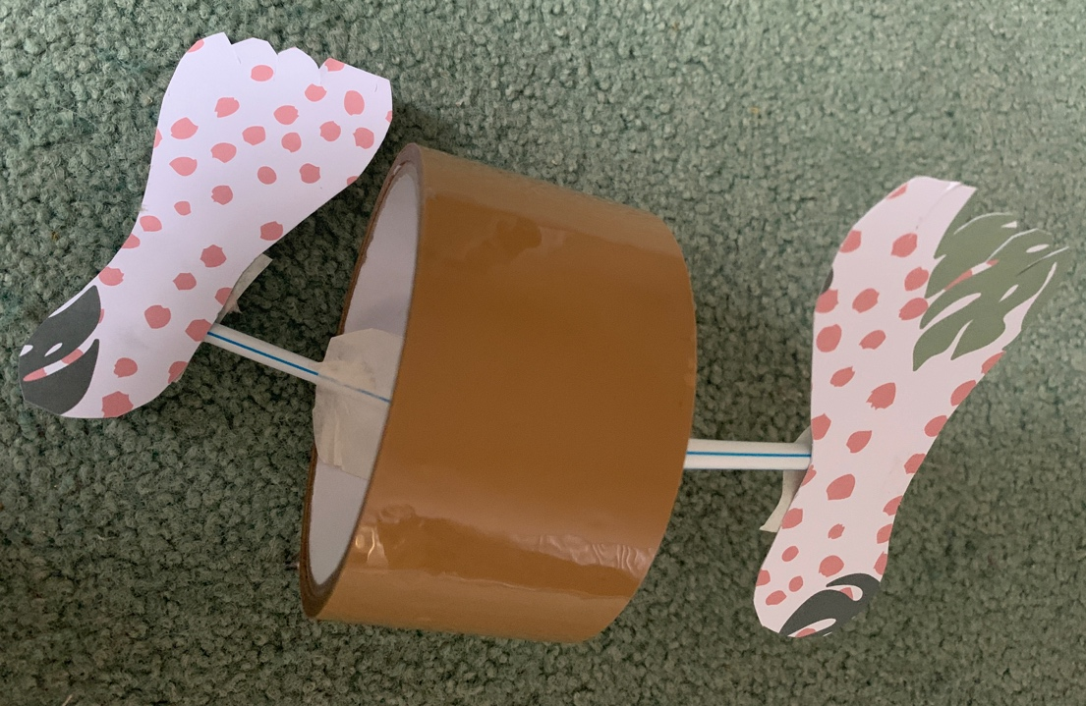
Cut a straw into pieces about 6cm long. Tape the end of one piece to the left-hand inside of the tube or roll and hold the tube or roll so that this piece is at the bottom. Take another piece and tape it to the inside of the tube or roll, but this time at the right-hand side of the top. Look at the photo to help this make sense! Now cut out two ‘feet’ shapes. and tape one of the shapes to each of the ‘handles’ that the straws have made. Push the tube or roll forward and see the feet ‘walk’.

TOGETHER SESSION TWO
Jesus teaches
You will need: kitchen roll; water; two cups; permanent marker pen; water soluble felt-tip pens
Loving enemies is hard and sometimes it is only because of the love God gives us that we are able to love those we don’t get on with. This craft illustrates the coming together of two sides through love.
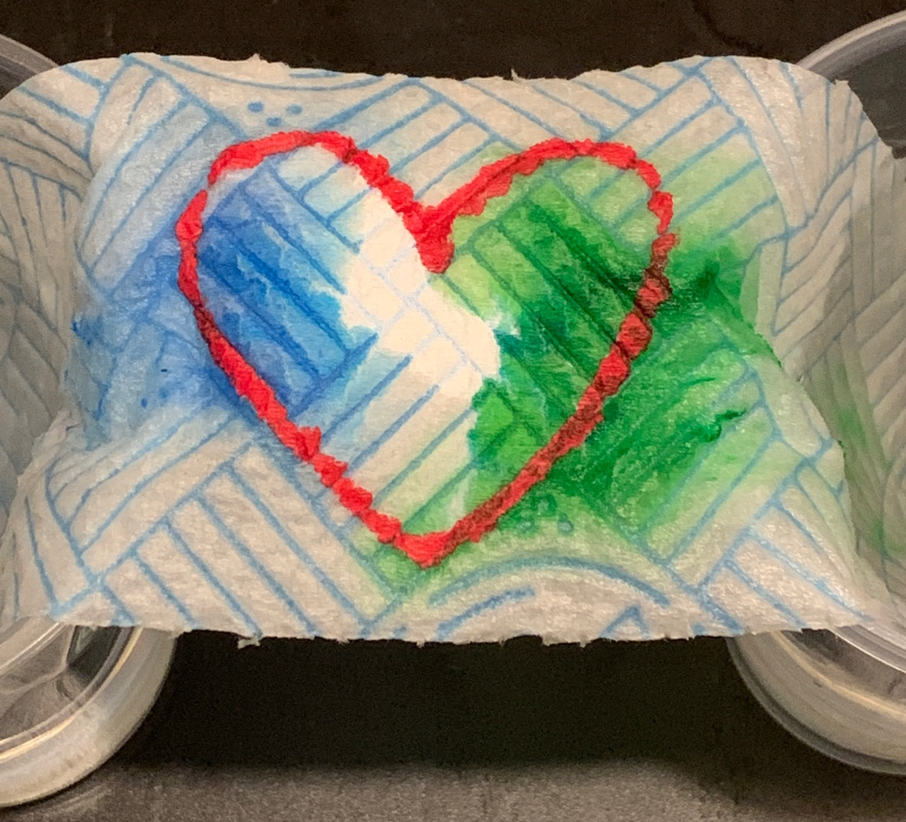
Cut out a strip of kitchen roll about 15cm long and 5cm wide. Draw a heart in the middle with the permanent marker. Use a felt-tip pen to colour a big rectangle to the right of the heart (make sure you don’t colour inside the heart). Use a different colour felt-tip to colour a rectangle to the left of the heart. Fill two cups with water and dangle each end of the kitchen roll in one of them so that the kitchen roll makes a bridge between the two. As the kitchen roll soaks up the water, the felt-tip pen colours will spread into the heart and eventually blend together.

TOGETHER SESSION THREE
Jesus performs miracles
You will need: a salad spinner; small paper plates; masking tape; paint in at least two different colours
This craft helps to illustrate Jesus as a bringer of calm in the storm.
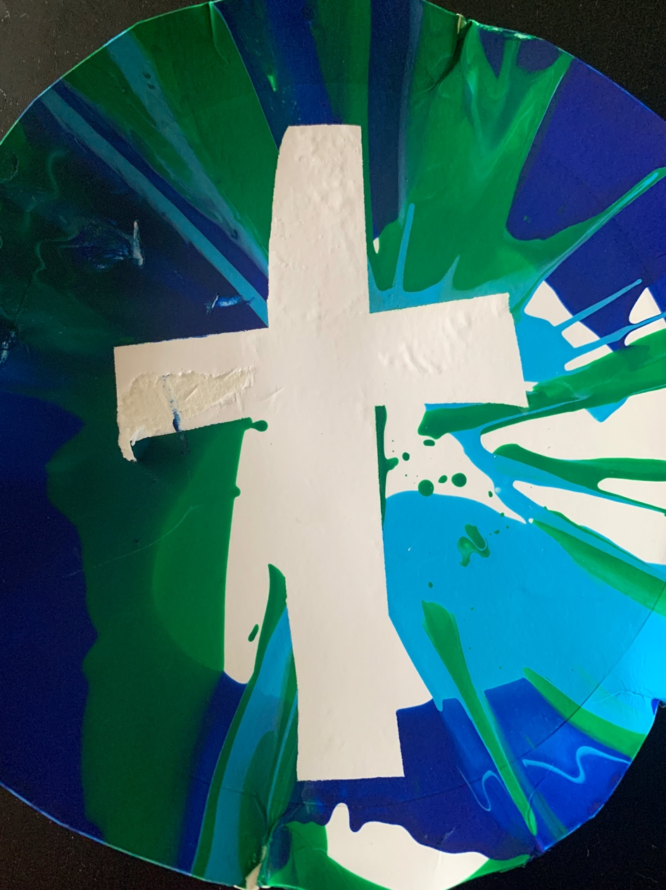
Cut out two strips of masking tape and use them to make a cross shape on the top of the paper plate. Place the paper plate in the salad spinner and pour some paint in swirls on top. Put the lid on the spinner and spin it as a reminder of the action of the storm. Take the lid off and see how the paint has been moved around. Wait for the paint to dry and then remove the masking tape. You will be left with a cross, unaffected and calm, in the midst of a ‘storm’ of paint.

TOGETHER SESSION FOUR
Jesus tells stories
You will need: a copy of the resource sheet; scissors; patterned paper; sticky tape; safety pins
The parable of the forgiven son is an amazing illustration of love reaching out, in spite of what has happened previously. This craft acts as a reminder of the embracing ‘love with arms’ that both God and the father in the story demonstrate.
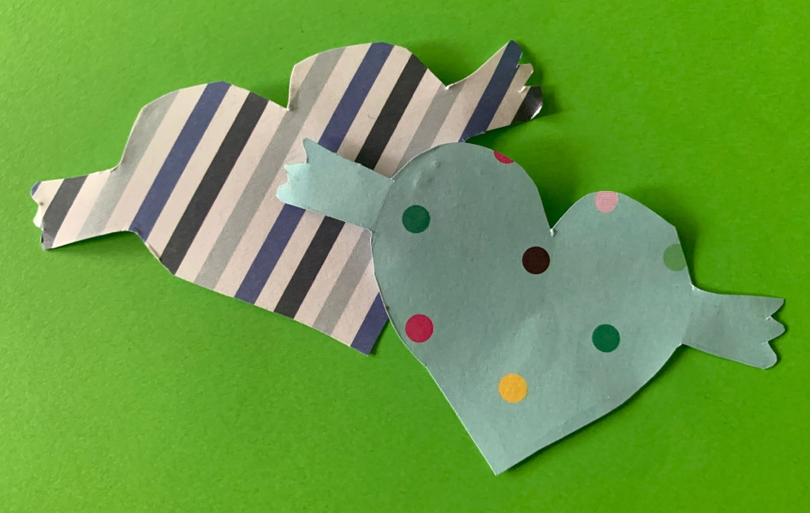
Take a copy of the resource sheet and cut out the heart-with-arms shape. Chat about the story and the action of the father when he opened his arms to his returning son. What would your response have been as the father? As the son? Either decorate the paper heart or use it as a template and to make a heart with arms out of patterned paper. Tape a safety pin to the back of the heart and wear it as a badge and a reminder of the love that God has for us, whatever we may have done in the past.

MINA MUNNS
is founder of Flame: Creative Children’s Ministry.

