READY TO USE CRAFT

Easter (part two)
Easter this year falls on 9 April, so our Easter sessions are spread across March and April. Use these craft ideas with April’s Together sessions, or combine them with those that featured in the March issue to create an Easter activity day.
_______
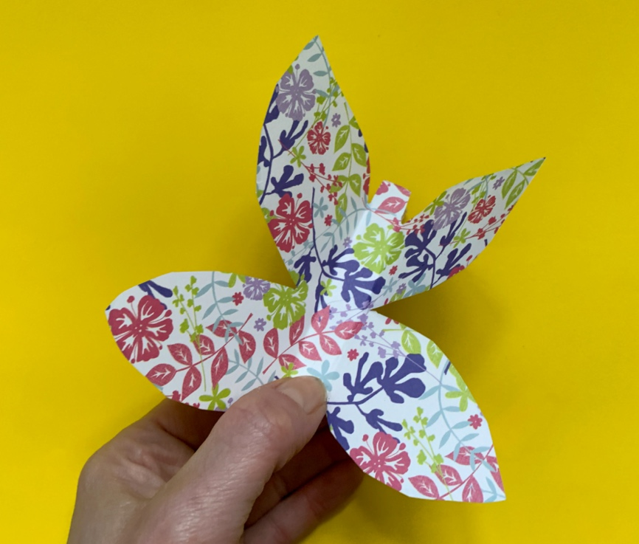

TOGETHER SESSION ONE

New-life butterfly
You will need: paper; pens; sticky tape; scissors; copy of the instruction sheet
The resurrection of Jesus is the hope for each of us that whatever has happened, we can have new life. Butterflies have long been Christian symbols of the resurrection. This craft shows children how to make a butterfly that moves with its own sign of life! Follow the instructions on the sheet to make a butterfly with flapping wings. Chat together about areas of life where you would like to see new life starting.

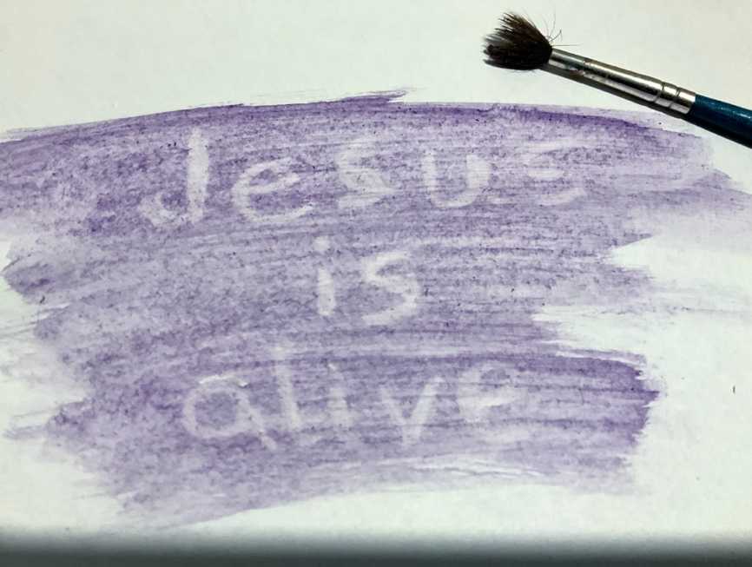
TOGETHER SESSION TWO

Invisible ink
You will need: white paper; white crayon or wax candle; paintbrushes; water; paint
Jesus reveals himself to Thomas, who has to see with his own eyes. This craft reveals something that is, at first, hidden from view. After listening to the story, use the crayon or the candle to write or draw on some paper. Write or draw something about Jesus or something about the story of Jesus and Thomas that most strikes you. What you put on the paper will be fairly invisible. Take some watered-down paint and paint over the top of the wax. What you have written or drawn will now be revealed!

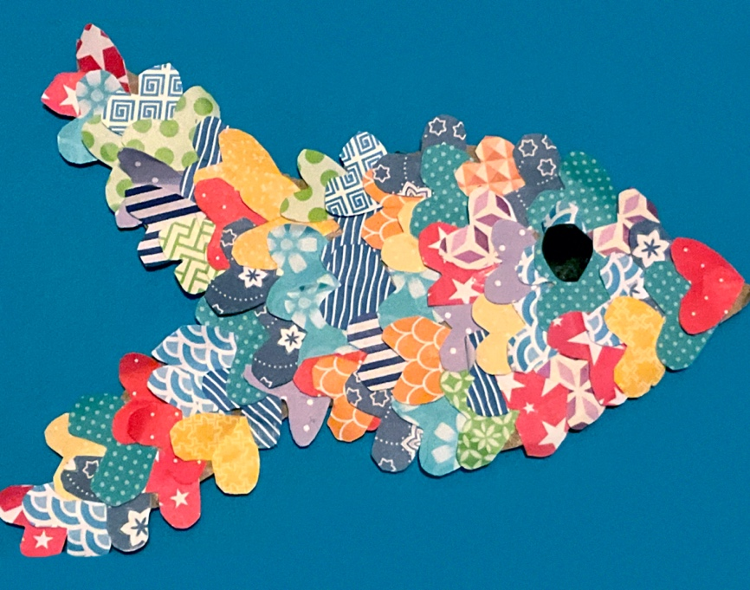
TOGETHER SESSION THREE

Fish sculptures
You will need: cardboard boxes; scissors; paper; glue sticks; foil; string; hole punch
Jesus appears to the disciples on the beach while they are fishing. They haven’t been able to catch any fish, but he tells them to cast the net to the other side of the boat and suddenly their net is full. Cut fish shapes out of stiff cardboard and use paper and foil to decorate them. You might want to stick on scales like the one in the photo. Punch a hole towards the top of the fish and put some string through it. Make a group mobile of the fish. Can you make 153 between you? What story does this one bring to mind from elsewhere in the Gospels? What does it tell us about who Jesus is and the job he has given the disciples to do?

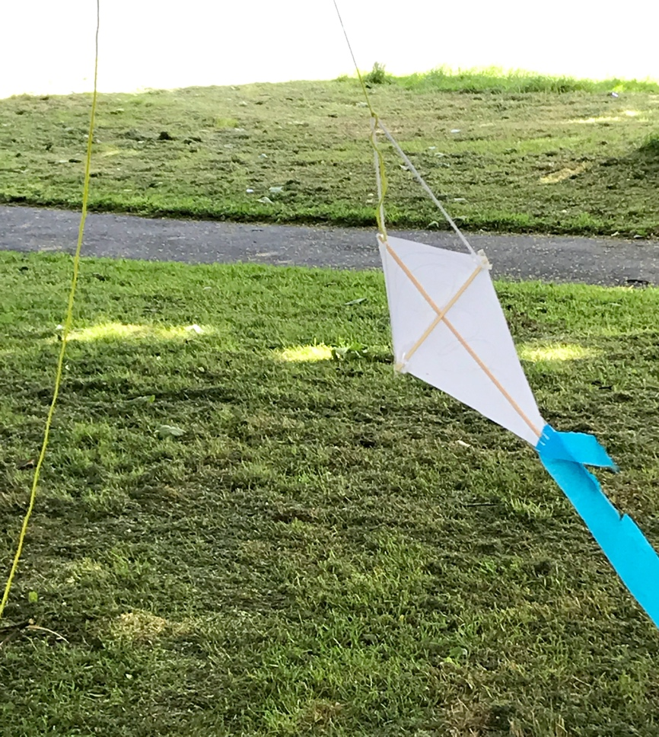
TOGETHER SESSION FOUR

Kites
You will need: printout of the kite pattern; string; long wooden skewers; scissors; felt-tip pens; sticky tape
Ascension celebrates Jesus ascending to heaven and this craft is all about sending things upwards! Print out the pattern of the kite onto A4 paper. Cut the kite out and decorate the front. You might want to draw a picture of Jesus to represent Jesus rising into the sky. Stick the skewers to the paper as indicated on the pattern. Tie the wool or string as indicated. Go outside when there is some wind and fly your kite. How might the disciples have felt when they saw Jesus ascending into the clouds?

MINA MUNNS
is founder of Flame: Creative Children’s Ministry.

