READY TO USE CRAFT

Christmas
This month’s craft ideas are all focused on Christmas! Use these craft ideas to explore these themes, either as part of a Together session or at a craft club or event.
_______

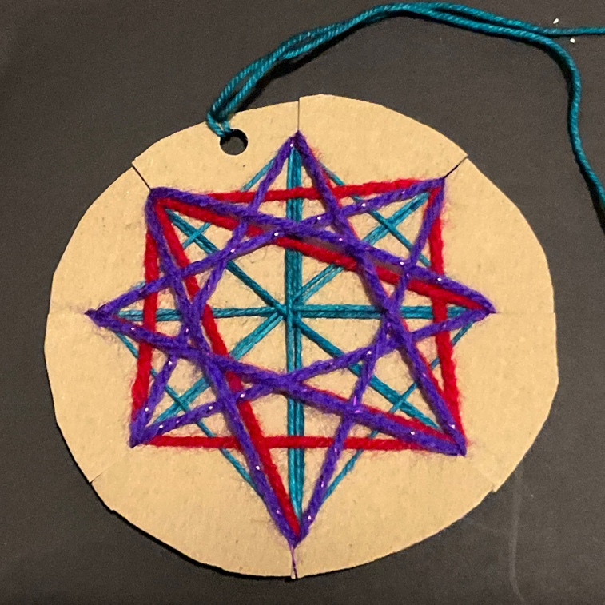

Hanging star decoration
You will need: cardboard; scissors; wool; hole punch
The wise men follow the star that points the way to where Jesus is. This craft offers a chance to discuss the meaning of this special star as you create. Draw round something circular and cut circles out of the cardboard. I used a roll of sticky tape to draw the circle in the paper and this is a good size to use. Make eight cuts around the circle (space them out evenly). Use different colours of wool to make a star shape, weaving in and out of the cuts you have made. Each star will look very different, as children use their imaginations. Tie each length of wool off at the back of the cardboard so that it can’t be seen at the front. Punch a hole in the cardboard where you want the top of the star to be and thread some wool through so that you can hang the decoration.

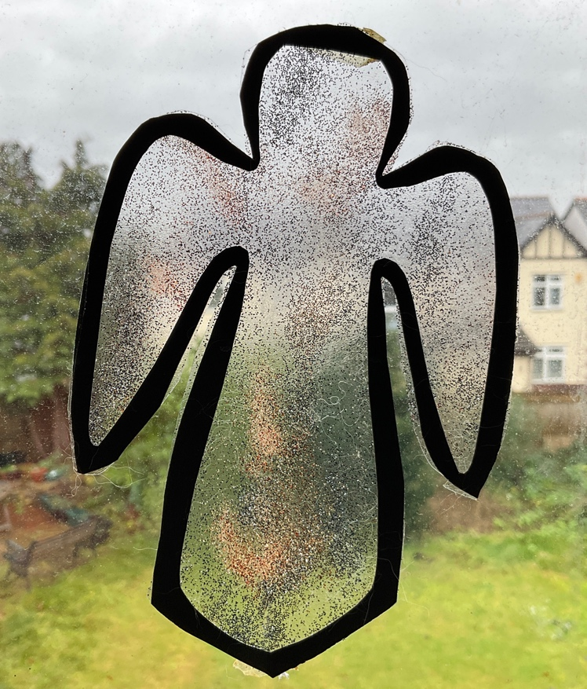

Angel suncatcher
You will need: black paper or card; sticky-backed plastic; glitter (eco-friendly if possible)
Angels crop up in various places during the Nativity story and, when they appear to the shepherds, we read that “the glory of the Lord shone around them” (Luke 2:9). This craft helps to capture some of that shine! Cut the outline of an angel out of black paper or card and lay it over the sticky side of some sticky-backed plastic. Sprinkle glitter onto the sticky plastic inside the angel shape and, when you are happy, trim away any excess plastic on the outside of the shape. Hang the angel in a window so that the sun shines through and catches the shine of the glitter.

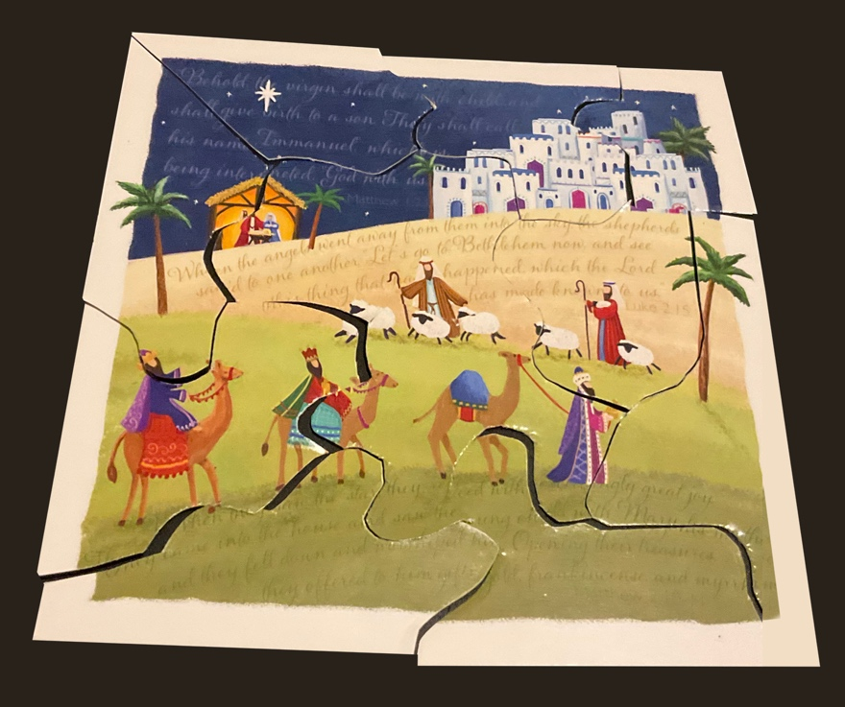

Christmas card jigsaws
You will need: used Christmas cards with Nativity story themes; pencils or pens; scissors
This craft is a great way to chat about the Nativity story and why we see certain images on Christmas cards. Cut the backs off the cards so that all you are left with are the front pictures. Make sure that everyone has a card of their own. Turn the card over so that the picture is facedown and, on the back of the picture, draw some ‘jigsaw’ pieces. I would recommend a maximum of eight pieces so that the jigsaws don’t become too difficult to complete. Cut the pieces out and then try to reassemble the picture. When everyone has completed their own jigsaw, swap with someone else. As you are doing this, use the time to chat about the images on the cards. Who are the people we see? What are they doing? What do the words ‘peace’, ‘joy’, ‘love’ and ‘glory’ mean? What parts of the Nativity story do you recognise?

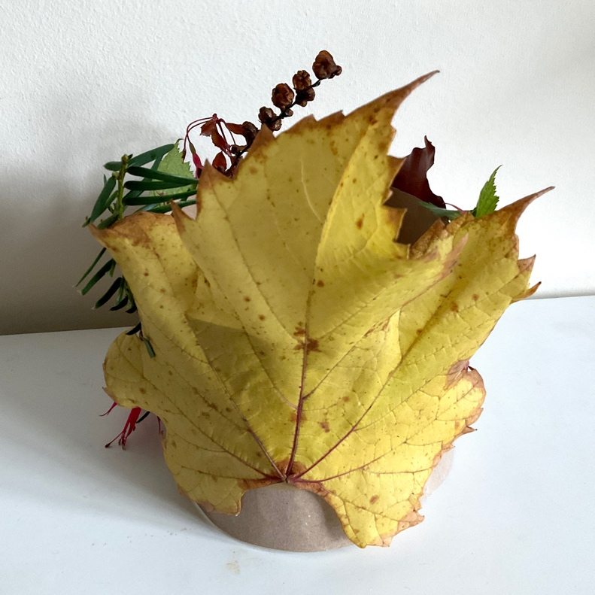

Nature crowns
You will need: paper or card; sticky tape or stapler; double-sided sticky tape; items from nature (go outside to collect them!)
The gifts that the wise men bring indicate that Jesus is a king, and this is a very different way to make a crown for such a king, using creation rather than glitter! Tape or staple paper or card around your head to make a basic ‘crown’ shape. Take the crown off and put a length of double-sided sticky tape all around the outside of it. You might want to use two or three lengths of tape if your tape is quite thin. Go outside and look at the different colours and textures you can find among the leaves and sticks. Choose some natural items to decorate your crown with and stick them onto the sticky tape. Make sure they’re not too heavy, or they might cause the crown to rip!

MINA MUNNS
is founder of Flame: Creative Children’s Ministry.

