READY TO USE CRAFT

Jesus is amazing!
The four stories explored in this month’s Together sessions all focus on amazing things that Jesus does and on how amazing Jesus is. Use these craft ideas to explore these themes, either as part of a Together session or at a craft club or event.
_______

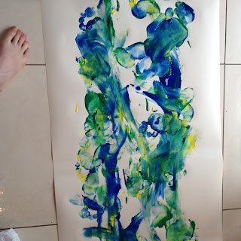
TOGETHER SESSION ONE

Foot painting
You will need: paint; wallpaper, lining paper or a long strip of paper; feet; washing-up bowls filled with warm water; old towels
This is a fantastic way of exploring the story of Jesus walking on water, but please be aware that it is messy!
Lay out the paper to make a long stretch of ‘water’ and make sure that it is fastened down! It is best to do this either outside or somewhere easy to clean. Squirt some blobs of paint onto the paper. Make sure they are small blobs because big blobs will cause a slipperiness problem for bare feet. Take off shoes and socks and step out onto the paper, use your feet to spread and mix the paint. Try using bubble wrap ‘shoes’ to make different textures in the paint. Several people can paint at once! When finished, help the children clean and dry their feet with the water and towels. Ask them how it felt, stepping out onto the paint. Were they worried?
Sometimes stepping out into the unknown requires you to be brave. Think about times in life when you’ve needed to have courage.

TOGETHER SESSION TWO
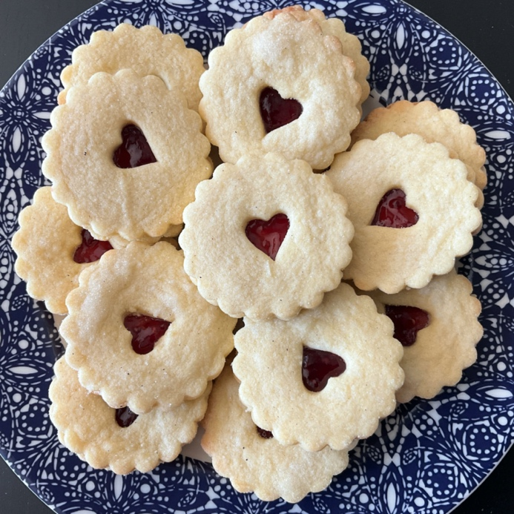

Biscuits
You will need: mixing bowl; wooden spoon; 150g plain flour; 50g cornflour; 100g butter; 50g sugar; milk; jam (red is best!); round biscuit cutters; a small heart-shaped cutter; oven; rolling pin; baking trays; salt
Grease your baking trays and preheat the oven to 180°C. Rub the butter into the flour until it resembles breadcrumbs. Mix in the sugar and a pinch of salt and then add milk (roughly two tablespoons) until the mixture becomes a dough. Add the milk gradually so that the dough is not too sticky. Roll the dough out until it is about the thickness of a £1 coin. Cut an even number of circles out of the dough – you should get between 14 and 18 from this mixture. Cut a small heart out of the middle of half of your circles. Put the biscuits onto the baking trays and bake for eight to ten minutes. Allow them to cool.
When cool, spread jam on the full circle biscuits and put a ‘heart’ biscuit on the top, so that the jam shows though the cut-out shape. Chat about the miracle of feeding 4,000 people. What does that provision say about Jesus’ love for the people who were there on that day?

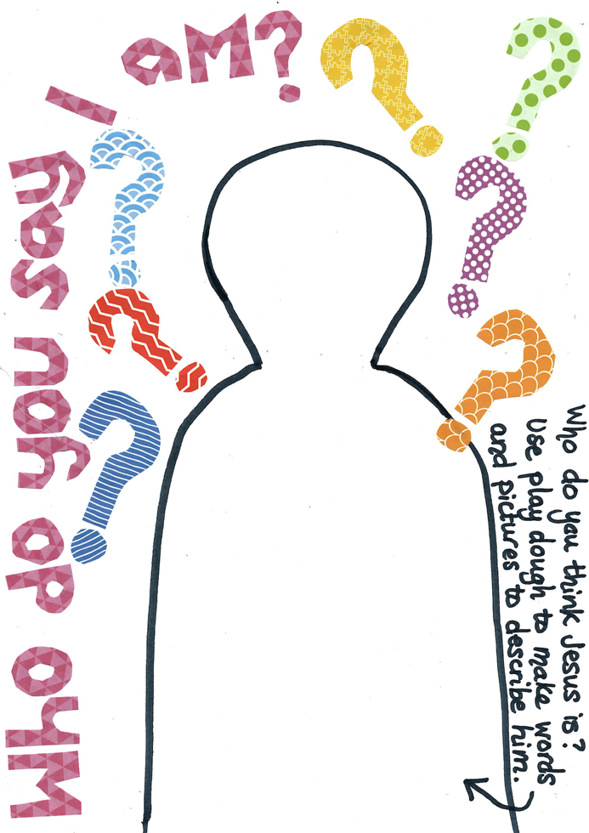
TOGETHER SESSION THREE

Playdough mat
You will need: copies of the playdough mat; playdough
Jesus asks his friends who they think he is, based on all they have seen and know about him. Peter says that Jesus is the Messiah. Ask the children who they think Jesus is, based on what they have heard and know about him. Use the playdough and the mat to explore words and images to describe Jesus.

TOGETHER SESSION FOUR
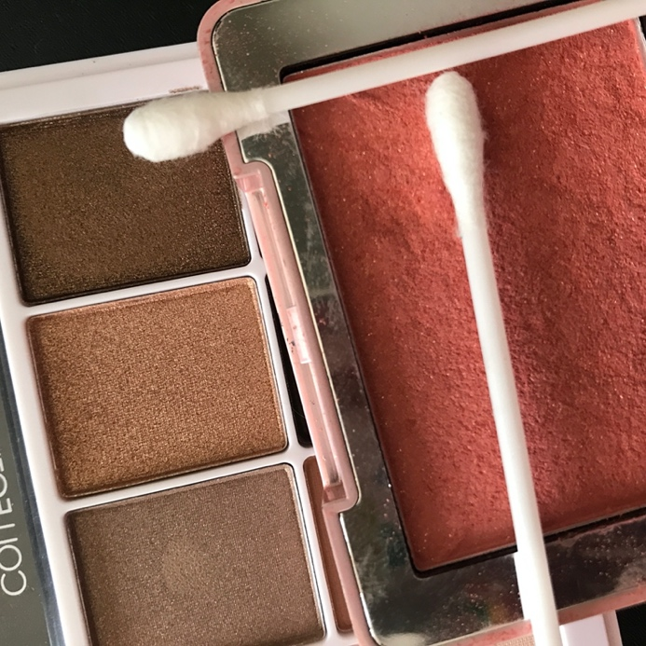

Transfiguration shine
You will need: paper; palettes of sparkly; glittery eyeshadow; cotton buds
The transfiguration is an amazing story of Jesus being transformed into blazing light, radiating God’s glory and giving the disciples with him a glimpse of who he really is. This activity helps children to connect with the shine of the story and to think about how they might be reflections of his light too.
Use cotton buds to paint the glittery eyeshadow onto paper, drawing pictures of Jesus or words about the transfiguration story. Children can also draw patterns with the eyeshadow on their hands and arms. Talk about how Jesus’ friends would have felt, seeing his transformation. How can the children be a reflection of who Jesus is in the world about them?

MINA MUNNS
is founder of Flame: Creative Children’s Ministry flamecreativekids.blogspot.co.uk.

