Going to Joy Club in Church



My name is _______________
and I love to…

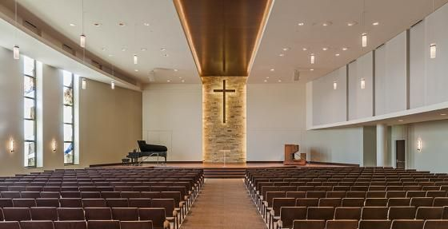

My family and me have started going to ___________church.

Church is a place where people meet together to sing, pray and learn about the Bible.



People are usually very friendly and happy to see each other when they meet at church.

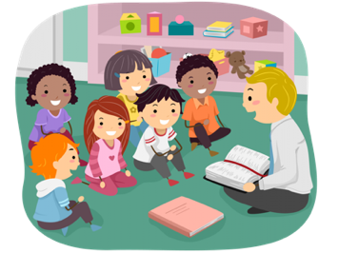
Church has a special group for children. It is called Joy Club.

Joy club is in the other room. The children wait for the leader to take them to the room so we can walk there safely and quietly.
This is what happens in the joy club. I can choose to join in or play in the quiet corner.

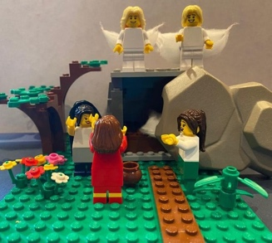

The quiet corner has Lego and some sensory toys. There are cards to give me ideas to make something about the Bible story. This is great if I want to do that.

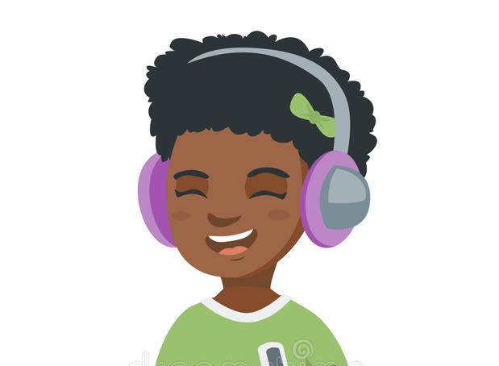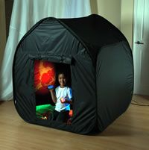

Sometimes the other children can be noisy. This is usually because they are having a fun time. This is okay.
When it is noisy, I can wear my headphones and go in the sensory tent if that helps. Brilliant.



The Joy Club leaders and the other children are really glad to have me in their group. They know that Jesus loves me and that I am important in their group. Brilliant.

When Joy Club is finished, we might go to the church café and then we go home. Well done me. I can go to Joy Club. I am loved.

